Collaboration and Problem Solving in Distributed Collaborative Learning

Hans Christian Arnseth, Sten Ludvigsen
University of Oslo

Barbara Wasson, Anders Mørch
University of Bergen

Abstract
Ethnomethodology and Conversation Analysis are utilised as resources for analysing distributed collaborative learning. Thematically we are interested in how a group of students manage their task, how they keep a joint focus, and how technology features in their activity. We present and analyse extracts of data from a group collaborating in a groupware system called TeamWave Workplace. We conclude that in collaborative problem solving the interpretation of the task and the problem solving process, is something that is jointly and continuously produced by the participants throughout their interaction. Another finding is concerned with how the participants utilise technology to perform actions. Technology does not determine action in any simple sense, on the contrary, technological tools are closely intertwined with the activities in which the students are engaged.

Keywords: distributed collaborative learning, discourse, social interaction, technological tools.

Introduction
Collaborative learning is a complex phenomenon, and research is conducted on many different analytical levels and from a range of different theoretical and methodological perspectives. The present study represents an attempt to analyse the use of technological tools for distributed communication, collaboration and problem solving as a discursive activity. Our theoretical perspective and analytical orientation are influenced by Ethnomethodology and Conversation Analysis (CA) (Atkinson & Heritage, 1984, Button 1991, Heritage, 1984, Hutchby & Woofitt, 1998).
Recent developments of advanced information and communication technologies have spawned a great deal of research on how these technologies feature in different learning activities. The related issue of cognition, or the relation between cognition, collaboration and different kinds of ICT-tools has also been, and is, an issue that is both prominent and widely discussed within the field of CSCL (Dillenbourg, 1999, Lehtinen et al, 2000, Littleton & Light, 1999, Vosniadou et al, 1996).
Much of the earlier research on computers and learning was dominated either by attempts to delineate how technological tools affect reasoning, conceptual understanding and problem solving, or how issues concerning problem solving strategies and collaboration processes and -patterns affect the use of different artefacts (Koschmann, 1996).
With the emergence of CSCL the importance of social practice and sociocultural and material artefacts for thinking and problem solving has been emphasised. In spite of this shift, cognitive processes are often understood as something that is displayed in and triggered by discourse. Therefore, even though the focus is on the interplay between technology and social action, essentialist assumptions of technology, culture, as well as a communication model of language, are often retained. These conceptions can lead to problems when accounting for the relationship between artefacts, cognition and social interaction.
We believe there is a need for studies that examine how technology actually features in social activities – in this case, how participants negotiate the meaning and usability of different tools. Psychological topics, such as perception, problem solving, remembering and reasoning, are also approached as something that is closely intertwined with social action, and which is managed in social interaction as a part of participants’ practical concerns. Their understandings are founded on culturally shared procedures for constructing meaning in context. These procedures do not determine social action in any simple sense, but the participants reflexively invoke and orient to them in discourse (Schegloff, 1991).

Theoretical framework

The development of shared knowledge
Two recent and very promising attempts of understanding the relationship between interaction and different tools are pursued by Baker et al. (1999) and Dillenbourg (1999, Dillenbourg & Traum, 1999). They emphasize the importance of shared knowledge as a prerequisite for collaborative learning in distributed learning environments. Their understanding of language use is founded on Clark’s (1996) research, especially his key concept grounding as a category for describing the development of shared knowledge. Grounding is a process dependent on participant’s beliefs, their knowledge, available artefacts and other resources. Different tools create specific constraints and affordances for the grounding process, and thereby for learning.
In studies conducted within this framework, researchers are primarily concerned with categorising collaboration and communication according to degrees of shared understandings. For example, Dillenbourg and Traum (1999) adapted Allwood et al.’s four communication functions (access, perception, understanding, agreement) as classification categories for representing degrees (or levels) of shared knowledge in virtual workspaces.
According to this notion of language use, common knowledge is founded on inter-mental transmission of information elements which are coordinated in the communication. With such a view there is a tendency to study what Edwards (1997) calls “frozen moments”. These moments are either concocted for illustration, or are recorded in experimental settings. In many cases analyses of such moments are useful and valuable, but it can be problematic to apply categories identified in such analyses to explain naturally occurring interaction.

CA and Ethnomethodology
We use Ethnomethodology and CA as theoretical and methodological tools for analysing computer mediated interaction. Within this framework social interaction is understood as accountable action, and the issue for analysts is to describe how people make sense of each other and their surroundings. Culture and cognition are not understood as determinants of meaningful conduct. This is not to say that peoples’ actions are totally idiosyncratic and coincidental. On the contrary, the ways people make sense of their world are founded on shared procedures that enable them to co-ordinate actions with others and participate in meaningful communication.
Important concepts that account for these aspects of action are indexicality and reflexivity. Actions are indexed to the situation of their occurrence. The sense or meaning that particular actions have for participants, and for analysts, are tied to the local circumstances of their production (Suchmann, 1987). The concept of reflexivity refers to how situations are the product of the participants organized activities. Social reality is dynamically produced, maintained, or altered as both a process and a product of ordinary action (Heritage, 1984).
CA is in many ways the application of Ethnomethodology to the study of talk. Two complementary ways of describing CA is first as the systematic study of how talk performs social actions, and second, as the practical management of intersubjectivity (Edwards 1997:117). Heritage, paraphrasing Garfinkel, defines intersubjectivity as:

the intersubjective intelligibility of actions ultimately rests on a symmetry between the production of actions on the one hand and their recognition on the other... this symmetry of method is both assumed and achieved by the actors in settings of ordinary social activity (Heritage, 1984:179)

This depiction includes much of what CA-researchers understand as all pervasive in talk — its’ sequential organisation.

Collaborative construction of mutual understanding
Within this framework the analytic interest is not primarily concerned with the categorisation of collaboration and communication according to degrees of shared understandings. The concern is rather with how knowledge is invoked and deployed as part of societal member’s practical concerns.
It was one of Sacks’ (1992) seminal insights that talk and behaviour are designed by reference to how they will be heard and perceived. By saying or doing what we do in a particular sequential position, a particular reading of that action is made relevant for the recipient. The sequential organisation of interaction provide the participants with a set of resources for acquiring mutual understanding (Schegloff, 1991). This understanding is continually shaped and reshaped during the course of the interaction. Establishing the relevant context for making inferences of meaning is not easily solved. For participants it is a problem concerned with how they should respond to different utterances and actions.
The next turn proof procedure, which refers to how speakers (and analysts) by examining the recipients answer receive confirmation of his understanding of the utterance, is an important resource for managing intersubjectivity and joint understanding in talk. Through this and other related practices such as repair, participants continually construct and display their understandings, and negotiate each other’s positions in the interaction (Schegloff, 1991). But even if participants manage to establish understandings and repair misunderstandings through talk, this does not provide rock solid evidence of mutual understanding. Language provides a set of resources that enable participants to show each other which parts of their shared knowledge are relevant for making the interpretations necessary for some locally contingent purpose. The fact that people understand each other and are able to achieve the necessary alignment to solve some common problem is due to practical work by the participants.
Before we continue to describe the method and analysis, it is necessary to introduce the learning scenario and the groupware system in which this work is situated.

Research setting

The DoCTA project
Project DoCTA (Design and use of Collaborative Telelearning Artefacts) aims to bring a theoretical perspective to the design of ICT technologies that supports the sociocultural aspects of human interaction and to evaluate its use. In the first phase of project DoCTA (June 1998 - December 1999) we focused on the design and use of technological artefacts to support collaborative telelearning aimed at teacher training (Wasson, Guribye & Mørch, 2000; Wasson & Mørch, 1999). Various scenarios utilising the Internet were used to engage the students in collaborative learning activities. The VisArt Scenario (Wasson, 1999) produced the data used in this study.

VisArt and TeamWaveWorkplace
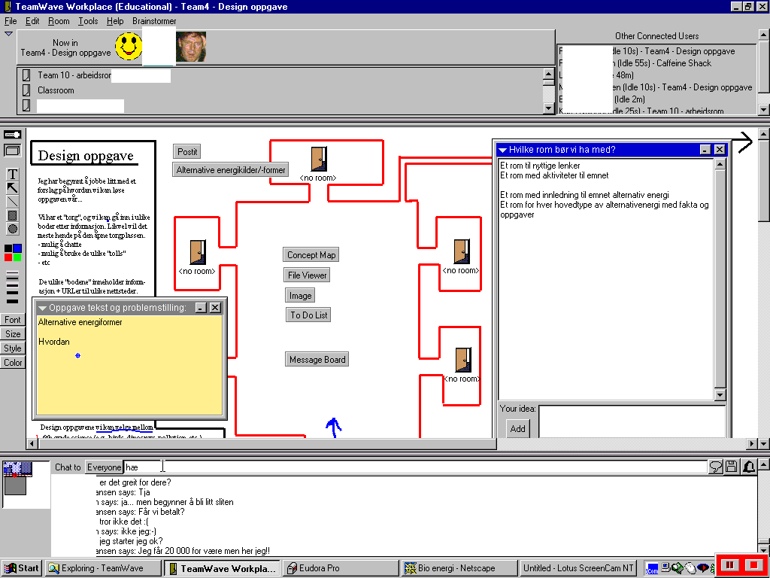The VisArt scenario involved students taking courses at three educational institutions (University of Bergen, Nord-Trøndelag College, Stord/Haugesund College) in Norway. Teams comprised of 3 students, 1 student from each institute, collaborated to design a learning activity. There were no opportunities for the teams to meet face-to-face. TeamWaveWorkplace (TW) was used as the main information and communication technology. The VisArt activity took place during February and March 1999. One week of training in using the TW tool and in collaboration proceeded three weeks of design activity. In the design activity, the teams designed TW room for learning about some topic they agreed upon. TW is based on the metaphor of shared networked places. Virtual team rooms provide a permanent shared space where teams can conduct meetings, store documents, share URL links and co-ordinate and communicate with one another. Each team can build a set of different rooms and each room can be customised by the team to suit their specific needs by using any of the 19 tools provided. The tools include: Address Book, Brainstormer,
Calendar, Chat, Concept Map, Database, Doorway, File Holder, File Viewer, Image Whiteboard, Meeting Roster, Message Board, Personalised Message, Post-It, ToDoList, URLRef, Vote, Web Browse, and the on-line help. Figure 1 shows a TW room with user-defined configuration of some of the tools. The team members are in the room as indicated by the icons along the top of TW—the happy face, the text data, and the picture, respectively.
Figure 1 Screen shot of group working together using TeamWave

Method
Ethnomethodology and CA imply certain analytical commitments and guidelines (Pomerantz & Fehr, 1997). First one should be cautious with letting the analysis be dominated by researcher stipulated categories. This is related to the problem of deciding which parts of the context that is relevant for determining the meaning of particular actions. According to Sacks (1992), any action, situation or identity can be formulated in a variety of ways. This poses a methodological problem when doing research and when drawing inferences on the basis of empirical data. Second the detailed analysis of actions as they occur sequentially is emphasised. The third issue is related to the understanding of rules and the relationship between rules and actions. Rules are treated as situationally invoked and closely related to specific activities.
We have examined selected records of the participant’s interaction from the VisArt scenario. We are in the process of segmenting the interaction data, which implies that this analysis is to be perceived as primarily an illustrative and preliminary analysis. We transcribed the chat and the text on the post-it notes. To grasp the relation between these aspects and other things the students did, for example how and where they moved their markers; we subjected the recording to repeated viewing.
We have transcribed the interaction as it happens sequentially. We’ve used a format that explicates all the text that is being written by the participants—Post-It entries indicated in plain text, Chat entries in italics—with additional descriptions of relevant actions in square brackets. This might decrease readability, but we believe that this information is necessary and relevant for the analysis. Note that the indication of pauses is not necessarily accurate in real time, due to different machine capacities and configurations.

Analysis

Collaboration as joint action
In the particular activity from which this extract is selected, the participant’s task goal is to create a learning environment on the topic of alternative energy sources for pupils in 6th grade. Such an activity involves different actions concerned with specifying and negotiating the task and formulating suggestions for how the task should be interpreted, understood, and carried out. All of these issues involve reflection and negotiation about the goal of learning activity, the knowledge domain, the resources that should be available, and the skills and knowledge required by the target pupils. In the following extract some of these issues are specified and negotiated in actual interaction.
The participants, Susan, Tony and Paul, are interleaving between different activities and tools. The tools they utilize are Post-Its and the Chat. The Post-Its function as a kind of collective memory for the group in that it enables them to save their specifications of the task for later reworking. What is being typed in the post-it is character-by-character visible to the others in the room. When it is necessary to pose questions, requests or suggestions due to some specific need, the Chat function is used for quasi-synchronous communication. With the Chat, the typer has to hit enter before the others see what has been typed.

1.Tony: hw [erases] how [erases how and a text fragment “alternative energyforms”]
2.Susan: [moves her pointer to the Post-It while Tony is erasing, then immediately starts writing on a Post-It entitled “Task and approach to problem:”] why
3.Susan: what are you planning to write there Tony? [Tony moves his pointer to another Post-It while Susan types her message in the Chat. Susan moves her pointer over Tony’s icon/avatar at the top, which displays that he is active and typing in chat. Susan extends the window of the Post-It then continues writing]
4.Susan: the name “alternative” energy sources?
5.Tony: It’s easier to continue if we have a problem to relate to…
(12.0 second pause)
6.Susan: more [Paul moved his pointer to the Post-It]
7.Susan: Which energysources do we have?
(5.0)
8.Susan: Which are healthy for the environment?
(39.0)
9.Susan: Advantages and disadvantages with the different types of energysources
10.Tony: Main problem: how to teach children in 6th grade about alternative energysources with the aid of CSCL.
11.Tony: ???
12.Paul: Sounds good [erases it immediately after he’s written it, and before Susan posts her message in Chat]
13.Susan: shall we presuppose that they are already familiar with the software?
14.Susan: if not it will be an extensive job [Susan moves her pointer to another Post-It called “What kind of rooms should we make”. Types “activities” then erases it.]
15.Tony: agree with you… we’ll presuppose that they can use TeamWave, and the tools that exist within it.
16.Susan: Activities for groups/collaboration
17.Paul: I agree
18.Susan: ok

Specifying and negotiating main task
Susan’s question in line-2 is a request for an explanation of what Tony is doing (line-1) and is to be heard as referring to the writing in the Post-It note. Her sentence is sequentially indexed to the previous activity he was doing, indicated by the use of his name and the reference to place. Tony perceives the question to be directed at him. Their utterances display that they have the necessary alignment. Let us speculate what Susan might have meant by her utterance. What was it that she tried to convey by using those specific words? The utterance could be doing at least three different things. First it could be a straightforward question. She was simply wondering what he was going to write, and what relevance it might have for their task and problem solving process.
Second it could be oriented to the fact that since Tony erases something from the Post-It, he is held accountable for explaining why he did it, perhaps because in group activities there is a social norm stating that individual actions must be co-ordinated with others actions and expectations. Since Tony neither explains why he erases something from the post-it note, nor produces another sentence that replaces it, he has in some way violated a social norm to which Susan calls attention.
A third possible interpretation could be that she is orienting to a possible interruption of Tony’s action. The Post-It allows only one to write at a time. In this case she orienting to her own actions as they might be violating commonly accepted norms concerned with interrupting others. One thing that counters this interpretation is that she might have formulated her self differently if she wanted to convey that she tried to avoid blame for interrupting Tony. She might have started the sentence with for example “I’m sorry, but what …”. When analysing naturally occurring interaction we encounter problems when trying to establish the meaning of an utterance seen in isolation. We need to look into the sequential unfolding of the activity to establish how the participants make sense of each other’s utterances.
If we look at Tony’s answer in line-5 we see that the second interpretation of Susan’s question is most likely correct. It is obvious that Tony doesn’t treat Susan’s utterance as a simple request for information. On the contrary, he is arguing for the requirement of a problem solving strategy, and he is also orienting to the activity as a collaborative effort.
The participants orient to and invoke norms governing interaction. In this particular case Tony does this to perform a particular local action. He is managing accountability by arguing for a particular problem solving strategy. Susan does not argue with Tony’s account. She simply continues to write on the post-it note. A question that arises is concerned with what it is with how Susan’s utterance is put together that make this particular reading relevant. It is difficult to establish exactly what it is with her utterance that makes Tony’s utterance appropriate, because the sentence does not have any features of delivery that are common in talk, like intonation, pressure and so on. Perhaps it is the use of the personal pronoun, which in some way constructs Tony as a group member with certain obligations. The sentence also has certain directness to it. It is somehow confronting Tony. Her utterance makes an account of what he is doing relevant. He can not simply say, “Well I was just writing something”. He has to account for what he was writing and how it was related to the activity they were engaged in. His actions are accountable to the groups’ collaborative efforts. Susan does not go through any efforts to repair her utterance either. This indicates that Tony interpreted it appropriately. Instead Tony elaborates on his account and reiterates their common task goal in line-10.

Orientation to social rules and norms
Another interesting aspect concerning how the participants are sensitive to each other’s actions are how Susan, while engaged in specifying the task, explicitly invites the others to join in (line 6) if they have comments. Since no one responds to her invitation she continues writing. She co-ordinates her activities with the others, by explicitly inviting them to partake in the process.
In collaborative activities like these there might be an objection if someone takes too much control. In that sense her actions can be interpreted as managing this potentially delicate issue. She's managing accountability in the sense that she later might be held accountable for not inviting the others to collaborate in the problem solving process. In this sense the sentence “more” does two different things. It is both an invitation to participate, and an orientation to the social rules and norms that govern collaboration processes. Collaboration processes are composed of locally situated actions like these, where participants do not necessarily co-ordinate mental representations, but are sensitive to norms and rules governing social interaction.

Need for quick acknowledgement
After reiterating their task goal in line-10 and perhaps requesting acknowledgement in line-11 Tony gets it from Paul in line-12. It is interesting to note that Paul is answering using the post-it note instead of the chat. Although he erases it immediately, it is perhaps an indication of the need for making quick answers when this is appropriate. Chat does not provide the same opportunity for giving an immediate answer (Garcia & Jacobs 1999).

Question or assertion?
In line-13 Susan introduces a new topic by asking a question, or at first it appears to be a question. If we take a closer look it might be read as an assertion since in line-14 she underlines that this is the preferred way to interpret the utterance. Tony shows that he interpreted it this way in line-15 and agrees with Susan’s assertion. Paul agrees in line-17 and Susan’s acknowledges this in line-18.
The establishment of some kind of joint focus or common interpretation is a presupposition for doing joint problem solving. But it is also important to notice that this can conflict with individual work. The relations between individual work and collective decision making are continuously negotiated. This is illustrated in this particular case by the way the participants co-ordinate the production of statements in Post-Its with the actions of the others.
We now turn our focus on two thematic issues concerned with the interactional management of references to knowledge and objects to perform specific tasks, and how constraints and affordances provided by technological tools interacts with the activities of the participants.

Invocation of knowledge and objects
An important aspect of co-ordination and collaboration is related to the use of reference terms to attract the other participants’ attention to specific places or objects that somehow are important to perform some joint task. Issues concerned with how this invocation works, for example how it is related to the particular sequencing and selection of terms and what implications this has for the problem solving process, are important topics to pursue further. There are to instances in this particular extract where these issues are played out in interaction. One concerns the reference to place and selection of recipient, and the other concerns the invocation and reiteration of common knowledge. Susan’s question in line-3 together with Tony’s answer in line-5, is an example of how participants make sense of each other’s actions on the basis of specific terms. It is obvious for Tony that Susan is referring to him and to a particular place in the room. It seems to be the case that terms like there and here are used to refer to specific places and locations in the environment. Complex terms are not used if some simpler term is available and appropriate for the participants.
Another issue is related to Tony’s invocation of common knowledge in line-10, which in this case, is the main task that they are supposed to solve. The object is invoked to perform a particular local action. It is tied to his response to Susan’s question in line-3. The selection of terms is, in this way, tied to local contingencies. It can therefore be problematic to infer to cognitive understandings from the participant’s use of concepts, or to infer a participant’s understanding of complex knowledge on the basis of these kind of situated actions. Issues concerned with individuals private understandings are as we can see closely intertwined with publicly accountable action.

Technological tools and social actions
As we mentioned above a problem with Chat is its quasi-synchronous character. The sequential aspects of talk become rearranged, because the utterances are not necessarily related even if they appear in next positions (Garcia & Jacobs, 1999). There is a delay between the production and the posting of the utterance, and this might pose problems for the participants’ sense-making processes. It does not seem to be a substantial problem in this extract. This might be due to the character of their interaction. They are not really in need of continuous synchronous communication. The main activity is to specify subtasks and the chat is mainly used as a co-ordination tool. However, perhaps Paul’s utterance in line-12 is an indication of a minor problem with Chat. He uses the Post-It to respond to Tony’s question in line-11, because this particular tool gives the opportunity for immediate feedback.
In another group (illustrated in figure 2) the participants found a way around this problem when they needed to communicate synchronously, that is, when they needed to co-ordinate some activity, recall and discuss earlier work that had been done, and plan future activities. The participants used the Post-Its as a Chat, that is, they created a chatroom by placing Post-Its beside each other and by putting their names as headings. These tools provided them with the opportunity to monitor what the others where saying and respond at the appropriate time. By organising their communication in this particular way, it became easier for the participants to monitor each other’s utterances. This is important when doing synchronous interaction because the participants can co-ordinate and make sense of each other’s activities, react properly and respond at the right time to questions, assertions and arguments. This illustrates the way different tools created different constraints and affordances, and how these are intertwined with the activities of the participants (Heath & Luff 2000).

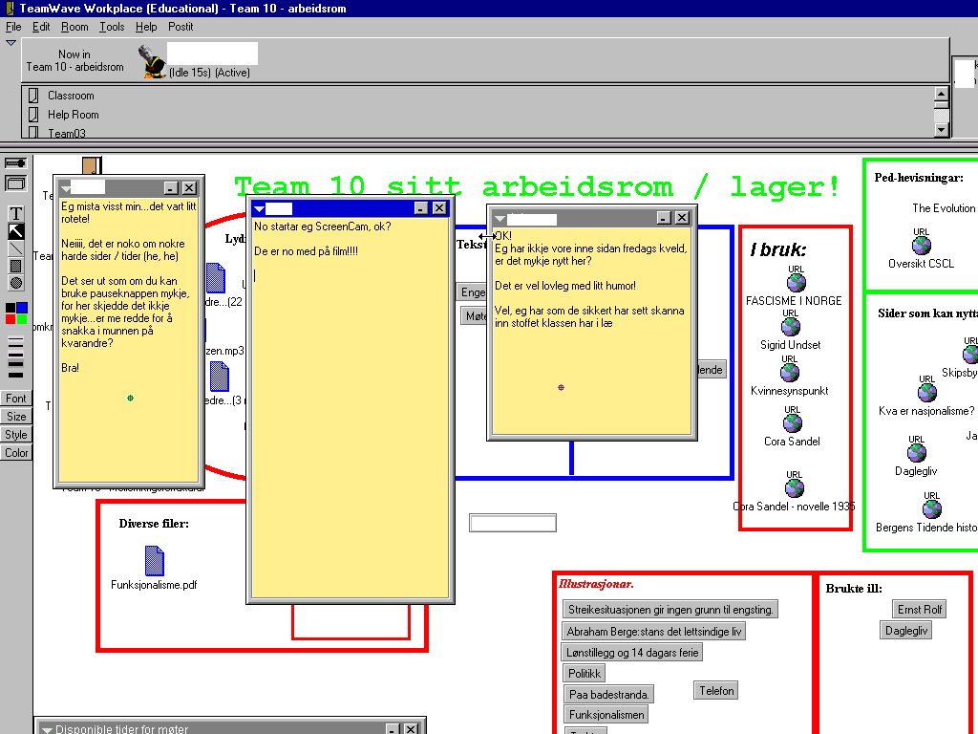

Figure 2 Screenshot of group doing synchronous communication using Post-It notes

Conclusions
We have tried to show, by analysing one extract of data, how the collaboration process is something that is continually negotiated by the participants. They negotiate the structure of the problem solving process, their understanding of the task and their different roles and identities. Another issue concerns the indeterminacy of technology, that is, how technology is used by participants to perform social actions. The use of the Post-It to conduct synchronous communication show how a technological tool that not necessarily was designed for that purpose, is utilised by the participants because it provides certain affordances that are important for the participants.
Another important implication is related to methodological aspects concerned with unit of analysis. In experimental studies there is a tendency to focus on “cognitive” talk, that is, talk which is a precondition for the attainment of knowledge. This way of analysing data can be misleading when we try to understand computer-supported collaboration and learning in more naturalistic settings. The collaboration process is comprised of accountable actions concerned with framing the task and understanding and carrying it through, and is therefore primarily social in nature. Which cognitive processes are triggered by these social interactions is a question that is difficult to answer because, as we have shown, it is problematic to infer cognitive processes or representations from discursive data without losing the situated and contextually determined sense of social interaction. We need to analyse how the social and material are intertwined in complex ways in problem solving. We believe there is a need for studies that utilise this approach to understand how people learn, collaborate and use tools in distributed environments.

References:
Atkinson, J. M. & Heritage, J. (1984). Structures of social action. Cambridge: Cambridge University press.
Baker, M. et al (1999). The role of grounding in collaborative learning tasks. In Dillenbourg, P. (Ed) Collaborative learning: Cognitive and Computational Approaches. Oxford: Pergamon.
Button, G. (1991). Ethnomethodology and the human sciences. Cambridge: Cambridge University press.
Clark, H. (1996). Using language. Cambridge: Cambridge University Press.
Dillenbourg, P. (1999). What do you mean by collaborative learning? In Dillenbourg, P. (Ed): Collaborative learning: Cognitive and Computational Approaches. Oxford: Pergamon.
Dillenbourg, P. & Traum D. (1999). The long road from a shared screen to a shared understanding. Proceedings CSCL 1999.
Edwards, D. (1997). Discourse and cognition. London: Sage.
Garcia, A. C. & Jacobs, J. B. (1999). The eyes of the beholder: Understanding the turn-taking system in quasi-synchronous computer-mediated communication. Research on language and social interaction 32 (4), 337-367.
Heath, C. & Luff, P. (2000). Technology in action. Cambridge: Cambridge University Press.
Heritage, J. (1984). Garfinkel and Ethnomethodology. Cambridge: Polity Press.
Hutchby, I., Woofitt, R. (1998). Conversation Analysis. Principles, practices and applications. Cambridge: Polity Press.
Koschmann, T (1996). Paradigm shifts and instructional technology: An introduction. In Koschmann, T (Ed) CSCL: Theory and practice of an emerging paradigm. Mahwah, NJ: Lawrence Erlbaum Ass.
Lehtinen, E., Hakkarinen, K., Lipponen, L., Rahikainen, M. & Muukkonen, H. (1999). Computer supported collaborative learning: A review of research and development. In J.H.G.I Giebers (Ed.) Reports on Education, 10. Department of Educational Science. University of Mijmegen, The Netherlands.
Littleton, K. & Light, P. (1999). Learning with computers. Analysing productive interaction. London & New York: Routledge.
Pomerantz, A. & Fehr, B. J. (1997). Conversation Analysis: An Approach to the Study of Social Action as Sense Making Practices. Van Dijk. T. A. (Ed) Discourse as Social Interaction. Discourse Studies: A Multidisciplinary Introduction Volume 2. London: Sage.
Sacks, H. (1992). Lectures on Conversation I and II. Cambridge: Blackwell Publishers.
Suchmann, L. (1987). Plans and situated actions. Cambridge: Cambridge University press.
Vosniadou, S., De Corte, E. Glaser, R. & Mandl, H. (1996). International perspectives on the psychological foundations of technology-based learning environments. Hillsdale, NJ: Lawrence Erlbaum Ass.
Schegloff, E. A. (1991). Conversation analysis and socially shared cognition. In Resnick, L., Levine, J. M. & Teasley, S. (Eds): Perspectives on socially shared cognition. Washington: American psychological association.
Wasson, B. (1999). Design and evaluation of a collaborative telelearning activity. In C. Hoadley (Ed) Proceedings of CSCL99 Designing new media for a new millennium: Collaborative Technology for Learning,Education, and Training, 659-666. ACM Press.
Wasson, B. Guribye, F. & Mørch, A. (2000). Project DoCTA : Design and use Of Collaborative Telelearning Artefacts. ITU Research Report, 5, 380 pages. Unipub Forlag : Oslo.

http://www.teamwave.com
Their online interaction was recorded using a screen cam. (www.lotus.com).
We are in the process of segmenting the data and we have only used data from one of these segments in this paper.
This is an wareness function in TeamWave, that displays in text what the selected participant is doing in the room. Author’s adresses Hans Christian Arnseth (h.c.arnseth@ped.uio.no) Department of Educational Research, University of Oslo, P.O. Box 1093, 0317 Oslo, Norway Sten Ludvigsen (sten.ludvigsen@intermedia.uio.no) Intermedia, University of Oslo, P.O. Box 1161, 0318 Oslo, Norway Barbara Wasson and Anders Mørch (barbara.wasson@ifi.uib.no, anders@ifi.uib.no) Department of Information Science, University of Bergen, P.O. Box 7800, 5020 Bergen, Norway

