Building a European Internet School: Developing the OTIS Learning Environment

Gillian Armitt (1), Sharon Green (2) & Martin Beer (1)
Departments of Computer Science (1) & Occupational Therapy (2), University of Liverpool, PO Box 147, Liverpool L69 3BX, United Kingdom

Abstract

This paper describes the development of the learning environment for the Occupational Therapy Internet School (OTIS). The OTIS project is a feasibility study for providing Internet based courses in health care disciplines. Courses use a problem based learning approach to promote collaboration between students based in several different countries, who study and evaluate the different strategies for assessment and treatment of patients across Europe. Courses are developed collaboratively by the partner institutions. OTIS is now delivering a pilot programme to occupational therapy students in four colleges in Belgium, the Netherlands, Sweden and the UK.

The OTIS system comprises a Virtual Campus based on MOO technology, specifically developed to promote a problem solving approach and collaboration between students. The intention is to use the core OTIS system to develop courses in other health care disciplines, so the system architecture comprises a generic core common to all courses, and a course-specific element capable of rapid development in response to on-going evaluation and as partner institutions exploit new opportunities offered by Internet technologies. A number of practical issues generally applicable to developing future courses are discussed.

1 Introduction

In many health care disciplines, practitioners work in teams to communicate and collaborate with a wide range of clients and allied professionals. It is very important that health care students in higher education gain significant experience of teamwork with people from a wide range of backgrounds, as well as developing problem solving and analysis skills. It is also desirable for students to explore the international dimension of their subject. There may be significant differences in how the subject is practised in different countries, and students should be able to evaluate the merits of different approaches. Some will take the opportunity to work abroad: a newly qualified occupational therapy graduate with UK state registration can practise in any European country and many others worldwide.

The Occupational Therapy Internet School (OTIS) project is funded via the European Commission's TEN-Telecom programme, and aims to promote collaboration and effective communication between students from different countries, enabling them to explore similarities and differences of approach to health care in their countries. Following an earlier pilot with nine students, an OTIS pilot course entitled "High Level Assistive Technology in European Occupational Therapy" is currently being undertaken by 23 occupational therapy students and postgraduates at the University of Liverpool (UK), the Hogeschool van Amsterdam (Netherlands), the Hogeschool West-Vlaanderen (Belgium) and Linköpings Universitet (Sweden). The course was developed collaboratively by occupational therapists in the partner institutions and the Department of Computer Science, University of Liverpool.

The intention is to set up further OTIS courses within the domain of problem solving courses in health care, involving collaborating partners in different countries. Accordingly, the OTIS system has been designed to be as generic as possible, in order to minimise the costs of developing further courses.

2 Educational Requirements

The OTIS system was designed in close collaboration with the occupational therapy partners, in order to ensure that the system supported the educational objectives.

(a) Educational philosophy

The first educational decision was the agreement that the course philosophy would encompass a problem solving approach, in which students learn through undertaking case studies. This approach is widely used in college-based health care courses. "Problem based learning has now been in use for more than 25 years and brings many real benefits to health professions' education" (1).

Medical courses using a formal problem based learning (PBL) approach present cases to the students for study in small groups, each facilitated by a tutor, and face to face feedback sessions are held regularly. It was recognised that while OTIS students would benefit from the use of a PBL approach, an Internet based course cannot meet the formal structure of problem based learning groups. Instead, the course design team aimed to develop essential professional skills by designing materials that should be addressed via the use of a problem-solving model (2). Students approach a problem by working through a series of problem solving steps:

- Data gathering - assessing the situation and gathering information
- Defining the problem
- Identifying the desired outcome
- Developing possible solutions and selecting strategies
- Developing an action plan
- Evaluating the effectiveness of the solution

(b) The OTIS course materials in support of the problem-solving model

The OTIS Internet system provides case studies for the data gathering stage and resources for developing possible solutions. The case studies must be attractively presented, and informative and interactive, if real learning is to occur (3). The OTIS system also had to provide comprehensive communication facilities to support all stages in the problem solving process.

Communication sessions are an integral part of solving the case studies. As well as collaborating with their peers and contributing to tutorials, students can interview 'patients' (tutors role-playing patients) and meet experts such as health care professionals and representatives of companies marketing health care products.

3 Analysis of Technical Requirements

The technical design arose directly from the educational requirements, with the additional requirement that the system should be developed to support rapid development of future problem solving courses in other disciplines. The technical solution had to be as generic as possible, with reusable components, and comprise a common core system for all courses, underlying attractively presented courseware rich in multimedia. It was also important that the technical environment should provide a rapid development medium for the courseware, as this would be developed in very close conjunction with the staff running the courses. An iterative approach to the development of courseware was anticipated, in the initial development as staff from different countries learn to collaborate together, and later as staff respond to student feedback and evaluations, and learn to exploit new opportunities offered by the Internet.

The key requirement for the core system in a problem solving course is the need to support synchronous (real time) communication between students, tutors, patients and experts. The communication facilities had to permit small groups of people within the virtual college to meet to discuss matters separately from other groups who might be meeting at the same time. The screen design had to allow space on screen for the case studies and other documents being considered, as well as for the communication session.

It was important for site navigation to be as intuitive as possible, to reduce the learning curve for new students and to encourage them to feel comfortable with the system. Students need to be able to find the case studies, library materials and course details easily, as well as locating other members of their communication group.

4 Technical Solution

4.1 Overview

The OTIS system design arising from the requirements analysis identified the need for a core system which would be common to all future courses, and a course-specific element comprising the course materials. The core comprises the user and document management facilities and communications. The course materials are developed in HTML using standard Internet tools such as Microsoft FrontPage, which provides a rapid development medium in which materials can readily be adapted in collaboration with the course tutors. Multimedia are developed using standard tools and 'plugged into' the HTML.

While the specifics of the course materials will be different for each new course, each course would be expected to comprise of the same general areas, such as case studies, reading materials and course guide documents. A generic skeleton structure within the HTML common to all courses was therefore envisaged, which would also provide the integration with the underlying core system.

4.2 Architecture

The basic architecture of the OTIS system is shown in figure 1. Both the core software and the user interface are based on a Virtual Campus metaphor (4) that comprises a number of virtual rooms such as the library, student work area, help desk etc. (5). This provides three advantages:

- more intuitive navigation around the system
- each virtual room engages the users currently in the room in a communications group
- the Virtual Campus provides a generic layer in the user interface which will be common to all courses

Figure 1:

OTIS Course Documents and Multimedia  (course-specific) | )  )  ) User  ) Interface  )  )  ) Core Interface  )
Virtual Rooms Environment  (same for every course) | )  )  ) User  ) Interface  )  )  ) Core Interface  )
Interface between Core and User Interface  (same for each course) | )  )  ) User  ) Interface  )  )  ) Core Interface  )
Central Core,  collaborative working environment  (same for each course) | )  ) Core  ) Software  )
Web server software | ) Web
Systems and backup software | ) Server
Hardware | ) (basic system  ) required for each  ) course)

4.3 Core Software

The core software provides communication and document management facilities, as well as handling user accounts and providing secure logins to the website. The CoMentor software package, developed by the University of Huddersfield (6), forms the basis for the core. CoMentor is based on a multi-user object oriented database, and uses the LambdaMOO (7) technology used for distributed multi-player adventure games.

Within the OTIS system, 'player' (student) objects have a property 'location' (virtual room) describing their current position in the virtual world. Players can 'Talk' to other players at the same 'location'. This allows students and teachers to meet by entering the same location or virtual room within the learning environment. Users can also 'Page' one or more users located anywhere throughout the system. Talk and Page conversations can be recorded for personal purposes so that records could be maintained for future study and analysis. All communication is currently text based, with students and tutors typing messages to each other in the chat box. Internal OTIS email is also available.

As well as login validation, the user management facilities permit the creation of pseudo-users, such as for example a patient, whose identity users can assume. During communication sessions, it appears that a real patient is communicating, rather than a role player. CoMentor also provides a personal area for each user, displaying the user's photograph and any personal details that the user wishes to provide. All users can view the personal area, which help to build bridges between people who may never meet each other face to face.

The CoMentor core has been enhanced to provide reusable modules, which can be plugged into the user interface as required. A meeting room booking system has been developed, which auto-generates meeting rooms when the booking is made. This module is used in the OTIS Meeting Rooms and Patient Consultation Area. A notice board module provides notice boards for all to see, but notices may only be pinned up by staff, or students, as appropriate.

4.4 Layout of the User Interface

The user interface is shown in figure 2, and is based on a two-part frameset specified within the CoMentor software. This splits the screen into a left hand area containing the course materials, and a right hand area providing the facilities offered by CoMentor. Within the course materials side of the screen is a further three-part frameset specified within the HTML code, described in more detail below.

The right hand side of the screen is divided into a lower 'action' area and an upper 'reporting' area. The action area provides a box into which users type messages, before clicking on the Page or Email buttons to select the recipients, followed by clicking on the Send button. When sending a Talk message, the user needs only to click on Talk, for the message to be received by all users in the same virtual room as the user. The People button gives access to a list of users and their personal areas. The Map gives a main map that can be used to return the user to the Entrance Hall and elsewhere if a user becomes completely lost.

The reporting area displays received Talk and Page messages, confirms the content and transmission of sent messages and the current position of the user, and reports on who is entering or leaving the user's current room.

Figure 2:
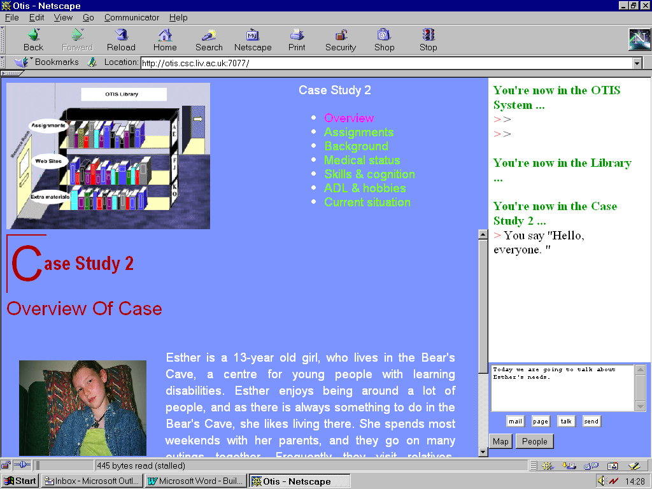

4.5 Virtual Rooms Environment

The virtual rooms metaphor in the core has been carried through to the course materials. The HTML documents comprising the course materials are laid out as a series of rooms in a virtual college. All rooms are accessed from one of two main maps (figure 3), and the relationship between the rooms is shown in figure 4.

Figure 3:

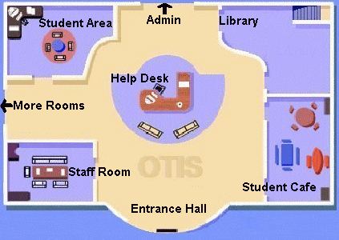 | 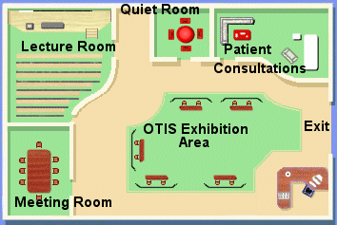
The OTIS Main Map | The OTIS Courtyard

Figure 4:
Admin
Area
Student Work
Area

Patient
Consulting
Area
Quiet Room Room

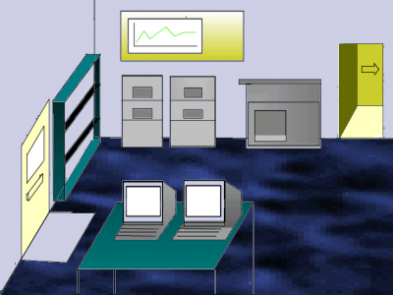
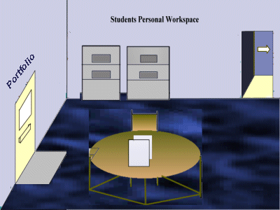
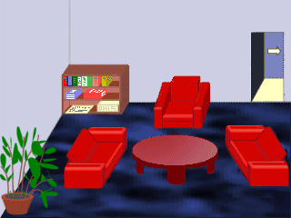
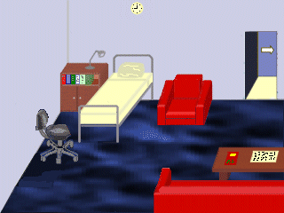
Course Materials

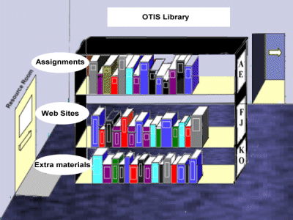
Supplementary
Reading
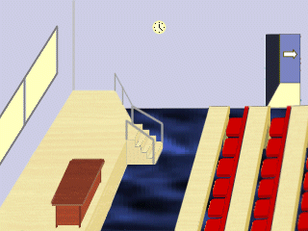
Web Links
Library
Lecture Rooms

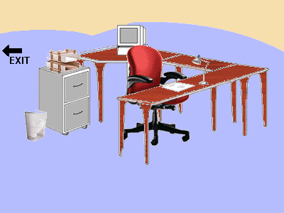
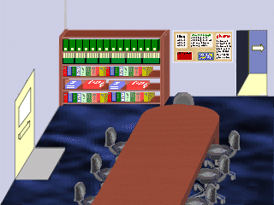
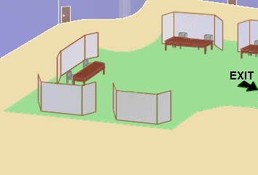
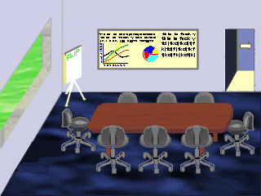
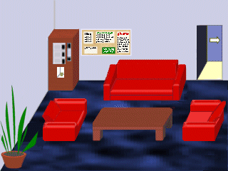

Exhibition
Area
Staff
Room
Student
Cafe
Help
Desk
Meeting
Rooms

Within each room, the left hand side of the screen displaying the Internet course materials is based on a series of generic three part frames, comprising a room map, a menu and a display area (figure 2). The first frameset for each room and its associated map, menu and display areas will be generic between courses, and the map is reused at each sub-level of HTML framesets within the room.
Quiet Room
Lecture Rooms
Meeting
Rooms
Staff
Room
Student
Cafe
Library
Admin
Area
Resource
Area

A common feature of the room maps is the door on the right hand side of each map (figure 2), which brings the user back to the OTIS Entrance Hall or Courtyard. This makes the OTIS system very easy to navigate, as the user is always one mouse click away from the central point. The table gives the functionality of the set of rooms:

Room | Functionality
Entrance Hall | The first room encountered when logging in, it provides access to six rooms and to the Courtyard. It contains the 'official' noticeboard, which everyone can read, but on which only staff can pin up notices.
Courtyard | A large subsidiary area, providing access to a further five rooms.
Library | Room containing the case studies and assignment materials, reading material, websites, web search and library search.
Student Work Area | The student's desk, giving access to their document management area
Meeting Rooms | Meeting rooms for students, tutors and others. The meeting rooms must be booked, and are created dynamically when meetings are arranged. There is no limit to the number of meeting rooms.
Lecture Room | A lecture room, still under development, which will allow online lectures and seminars to be given using audio-conferencing.
Patient Consultation Area | Bookable rooms, created dynamically, where virtual consultations are held with patients or with tutors role-playing patients.
Exhibition Area | An area providing bookable booths, where company representatives and others can display posters and other materials for the duration of the course or for a more limited period. The representatives can define times when they will man their booths and meet staff and students there, to discuss their products and provide additional information.
Computer Help Desk | An area where users can access technical documents and online technical tutorials. Problems can be reported here, by email or directly to technical staff who may man the help desk from time to time. The area also houses a list of FAQs (Frequently Asked Questions) which is built up during the course.
Administration Area | An area containing documents pertaining to the administration of the course, e.g. the course guide and prerequisites, the timetable, assessment guidelines etc. This area will also house the student registration system.
Student Café | A student-only area facilitating informal discussions between different groupings of people. The room also contains a notice board on which students can pin their own notices.
Staff Common Room | A tutors-only area, in which staff can communicate without being overheard by students and giving access to student assignments submitted for marking.
Quiet Room | An area into which students can retreat, if they wish to indicate to other people currently logged on that they are not currently available for communication. This enables students to leave their desks for short periods without logging off.

4.6 Interface between the Core and the User Interface

The interface between the core and the user interface is provided elegantly and simply by hyperlinks from the generic room maps to room objects within the MOO. A hyperlink call from the HTML to a room number not only repositions the user in the correct room frameset in the HTML, but also repositions the user within a new room in the MOO, thus respecifying the user's 'Talk' companions.

4.7 Scaleability

A procedure has been developed for cloning a basic system and using this as the basis for running future courses. In Liverpool, we have successfully run one 'live', one 'beta test' and two development environments concurrently on the same server over a period of several months.

5 Issues concerning Course-Specific Material

A number of issues potentially common to all future courses were addressed during development of the course specific materials.

5.1 Colours and Fonts

The HTML incorporates a cascading style sheet (CSS), which ensures consistency in the look and feel of the materials specifically developed for individual courses, as well as allowing the colours and fonts to be changed quickly, if the client desires an alternative.

5.2 Multimedia

Multimedia is essential in a project of this nature in order to illustrate the text and to provide additional information. For example, video and audio can be used to provide information about a patient. Even at low resolution, video and audio files are too large to be downloaded quickly over the Web, so a decision was made to supply such material on CDROM until such time as bandwidth for the average home user improves significantly. A consistency of approach was ensured by embedding video and audio in a HTML frameset based on the OTIS CSS.

An important feature of the problem solving approach is that tutors act as guides and mentors in the student's voyage of discovery, but should not 'spoon feed' information to the students. Great care had to be taken in the selection of supporting multimedia materials, to avoid adding information. Even the backgrounds in photographs had to be scrutinised, to ensure that no hints were given which might distract the student. It was important that the technical development team understood that nothing should be added, and nothing taken away without consulting the client.

Obtaining multimedia proved very time-consuming, owing to the legal safeguards of data protection and intellectual property rights. Much of the multimedia for health care courses comprises of photographs, audio and video of people. The European Directive on Data Protection (8) and its enactment in the different member states (e.g. the UK Data Protection Act 1998 (9)) provide that individuals must give permission for any part of their personal data, including their image or likeness, to be used by another. Explicit permission, e.g. in writing, must be given where medical and other sensitive data is concerned. All data subjects were required to complete a standard letter of consent. The status of the intellectual property rights (IPR) of all material in the OTIS library had to be ascertained. Where necessary, the owner of the IPR was identified and contacted, to request permission to use material on the restricted access student website. The effort involved varied widely.

5.3 Organisation of the OTIS Library

The organisation of the OTIS library of resources (links to websites, scanned and PDF documents) needed to support the problem based learning approach, which requires that students should not be told the answers, but encouraged to find solutions for themselves. It was important that items in the OTIS library should not be described in too much detail in a cataloguing system. However, some guidance for students was felt to be desirable, to prevent excessive time being wasted rummaging websites of limited interest, and excessive costs of web browsing from home. This problem has been solved by establishing a list of keywords, and attaching keywords to each library material. A library search facility allows all materials matching specific keyword or other word combinations to be identified.

6 Evaluation and Future Work

Evaluations during the first pilot course have shown that technically, the system is working well, with remarkably few problems. However, a significant improvement in the quality of communications can be achieved by introducing video- or audio-conferencing. Sending text messages is slow and tedious, and seriously limits the interchange possible in a one-hour conferencing session. Audio-conferencing using CentraNow is being trialled during the current pilot course.

Agent technology, interacting with the student and the learning environment (10) can be used to assist students and tutors. An agent helper can provide basic advice and assistance to the student at any time, even when the tutor is not available. It can interact with the agents associated with other group members to provide the feedback necessary to attain goals and meet deadlines. Agents can also help tutors monitor groups and counsel students who are not functioning.

The current system is based on a single server. As the course grows, student numbers will outstrip its capacity very quickly. The use of distributed 'whiteboard' technology is being investigated, to allow servers to work together to deliver OTIS courses seamlessly to much larger groups of students.

7 Conclusions

The OTIS learning environment has been developed in close collaboration with the course tutors and is based firmly on the educational philosophy of a problem solving approach. The first OTIS pilot course has shown that OTIS is a robust system with a capacity for rapid change as the course develops in response to evaluations and requests from the course tutors, but which could be further improved by providing conferencing facilities.

The system has been designed to provide a core system that will be the same for every future course, allowing the course-specific HTML and multimedia to be easily plugged into the core system. OTIS now has a core system comprising the communications, user and document management, and virtual rooms environment, and a simple hyperlink interface between the HTML and central core. While course-specific HTML can be developed rapidly, much of the courseware costs is associated with obtaining and using multimedia, and there is a significant cost with developing courses of this nature in complying with IPR and Data Protection issues.

This project shows how problem-based learning techniques can be used effectively in a distance-learning environment to bring members of highly practical professions together across many different countries, sharing and disseminating experiences and best practices across national boundaries.

Acknowledgements

The OTIS project is funded by the European Union through the TEN-Telecom programme. The system is based on CoMentor, developed by the University of Huddersfield, whose help in setting up the system is gratefully acknowledged. Certain of the software described in this paper was developed by the following MSc students at the University of Liverpool under the direction of two of the authors: Theo Hagos, Lee Kempson, Simon McCormack, Neil Mitchell and Alan Tierney.

References
- Davis M, Harden R (1999) AMEE Medical Education Guide No. 15: Problem-based learning: a practical guide. Medical Teacher 21 (2) 130-139.
- Hagedorn R (1992) Occupational Therapy: Foundations for Practice. Edinburgh: Churchill Livingstone.
- Boud D, Cohen R, Walker D (eds.) (1993) Using Experiences for Learning. Buckingham: SRHE & Open University Press.
- Maher M (1999). ‘Designing the Virtual Campus as a Virtual World', Proceedings of the Computer Support for Collaborative Learning (CSCL) 1999 Conference, pp 376-382.
- Ginsberg A, Hodge P, Lindstrom T, Sampieri B & Shiau D (1998) "The Little Web Schoolhouse” Using Virtual Rooms to Create a Multimedia Distance Learning Environment, ACM Multimedia 98, September 13-16, 1998, Bristol, UK, pp89-98.
- Gibbs G, Skinner C & Teal A (1999) ‘CoMentor: a collaborative learning environment on the WWW for philosophy and social theory students’, http://www.hud.ac.uk/comentor
- Curtis P, LambdaMOO Programmers Manual, Xerox Park, USA, August 1993.
- Directive 95/45/EC of the European Parliament and of the Council of 24 October 1995 on the protection of individuals with regard to the processing of personal data and the free movement of such data, Official Journal L281, 23/11/95 pp0031-0050.
- Data Protection Act 1998, Public General Acts & Measures, Chapter 29, HMSO, London, UK.
- Whatley J, Staniford G, Beer M, Scown P (1999), ‘Intelligent Agents to Support Students Working in Groups Online’, Jl. Of Interactive Learning Research, Special Issue on Intelligent Agents for Educational Computer-Aided Systems, 10(3/4), pp361-373.

