Project-Based Learning as a Basis for a CSCL Environment:
An Example in Educational Robotics

Sébastien George, Pascal Leroux
Laboratoire d’Informatique de l’Université du Maine (LIUM)
Avenue René Laënnec - 72085 Le Mans Cedex 9 - France
email: {george, leroux}@lium.univ-lemans.fr

Abstract
Project-based learning is a technique that has already proved its worth, mainly in traditional classroom learning situations. We feel that it is also interesting to use it in a distance learning context, particularly to encourage collective learning. It does, however, need to be set up carefully in order to be well adapted to this learning situation. This paper suggests organizing a project-based learning activity where participants work in teams, each team being made up of learners at a distance involved in the same project. A teacher, also at a distance, then assumes the role of project leader to monitor and help the learners. Giving the project a schedule is equally important, and we recommend structuring it in stages which are themselves composed of synchronous and asynchronous phases to give the project rhythm. To support this project-based learning in a distance context, we designed and developed a computer environment that comprises all the tools necessary for the collective activities (asynchronous and synchronous communication tools, an application-sharing tool, a scheduling tool and a tool to write reports). Finally, we describe an experiment using this environment with 13/14 years old schoolchildren in the field of educational robotics.
Keywords: project-based learning, computer supported collective activities, educational robotics

Introduction: context and research questions
We have been interested for several years in learning in the field of technology, which concerns both students during their initial formation and factory workers aiming at requalification [Vivet et al. 1993]. Work done at the LIUM has been more particularly directed towards the study and development of learning environments based on modular micro-robots which can be driven by a computer. The most recent work led to the design of the Roboteach software [Leroux et al. 1996].
Roboteach is a learning system aimed at helping learners to discover technology while browsing through electronic course books on micro-robot technology, but also through programming and driving the micro-robots they design and build during activities prepared by the teacher. As regards organizing the learning sessions, students work in groups of two or three to each workstation (computer with Roboteach and a micro-robot). In a classroom, a teacher works with 3 or 4 groups at a time (Figure 1).
Figure 1: Organization of a classroom using Roboteach
Our work originated in this educational robotics research context. The need for Roboteach to evolve towards a distance learning environment stems, on the one hand, from the desire of both companies (for reasons of economy, a need for flexibility when organizing training sessions) and schools (creating links between schools, introduction to new technologies) to move towards distance learning, while, on the other hand, distance learning makes it possible to create new and interesting learning situations, as we shall see.
The distance learning context led us to change our educational organization. Although the basic idea of learner groups working together with Roboteach and a micro-robot remains unchanged, the teacher and the various learner groups are now distant (this distance is shown by the dotted arrows in Figure 1). Links which were easily formed between the groups in a classroom will no longer be created so naturally. So that the groups are not isolated in this new distance context, our main center of interest will be to take into account the social aspect of learning. To enhance the learning experience we want to further communication and interactivity between groups of learners.
A study of research done into the social aspects of distance learning made us realize that the main area of work in the field of CSCL revolves around the computer tools that must be provided so that distant learners can communicate. Learners working together would only need a means of communication. We feel this is not always sufficient. It may be adequate in the case of communities of learners communicating in their common interest: communities of practice [Wenger 1998], knowledge-building communities [Scardamalia and Bereiter 1994], communities of learners [Sherry 1996]. However, outside such communities or as regards newcomers to distance learning, tools which simply offer technical possibilities for communication would appear to be insufficient in leading to collective activities. Indeed, although the learners are offered a possibility to communicate, there is no reason for them to do so if they have no common interests to bring them together. The lack of social cohesion renders truly collective learning impossible. The term collective learning [Jermann and Dillenbourg 1999] has been used in this paper in preference to those of collaborative or cooperative learning as our aim is to involve the learners in collective activities in which they will both cooperate and collaborate.
In order to create social cohesion in distance learning, our main concern is to concentrate on the collective activity to be set up. Thus distance should not be seen as an obstacle to which the computer tools provide a solution, but rather as an interesting learning situation in which the computer tools are designed to support new learning activities. This is the spirit in which we investigated the setting-up of distance collective activities using project-based learning practices.

Project-based learning as a basis for collective distance learning

The principles of project-based learning
Project-based learning is an educational method of creating collective classroom learning situations which has been tried and tested for many years. At the end of the nineteenth century, Dewey founded an experimental primary school at the University of Chicago where children were split into teams and worked together on real-life projects [Dewey 1902]. From a more theoretical point of view, Kilpatrick published an article entitled “The Project Method” in which he defines a project as an activity that has a specific purpose, in which the participants are totally involved, and that takes place in a social environment [Kilpatrick 1918]. This method advocates discovering solutions to real-life problems that occur every day. In France, Freinet tried to develop group work between learners [Freinet 1977] ; the project approach is one of Freinet’s techniques.
In the case of collective projects, several learners take up the study subject or activity, which leads to a division of the work. It is the students themselves who should divide the work, a division of work imposed by the teacher is a negative factor which leads to a lesser emotional involvement [Legrand 1986]. There can be no project without a specific purpose in mind. This purpose may be knowledge, or a technical or artistic production. In every case, the project should result in a realization that can take on many different forms. The desire to achieve this purpose is an important factor in collective and emotional involvement. Indeed, Bruner stressed the importance of such joint tasks in students’ group work. According to him, these collective tasks both create and maintain solidarity within the group, they help to build a community and they heighten students’ awareness of the necessity to divide the work to achieve an end product [Bruner 1998]. Furthermore one must make sure that students feel involved, or else the project will be bound to fail [Polman 1996].
The teacher’s role, in the project, is not to impart knowledge but to be a project consultant or assistant. In this sense, the teacher’s role is that of regulator and informant intervening on request or on his/her own initiative as the project advances [Legrand 1986]. At no moment should the teacher make a decision for those working on the project, but allow them to achieve their aim themselves, for instance by inviting them to consider certain specific points. Moreover, the project requires a certain amount of time management and planning. Among the principles of project methodology defined by Goguelin, the following can be noted: a project should be structured in time and broken up into its successive stages which form a provisional plan of action [Goguelin 1994]. Careful planning of the actions is necessary to give the project a temporal structure.

The contribution of project-based learning to distance learning
The first advantage one can expect to gain from using project-based learning in a distance context is that of creating a real need for interaction between learners. Such a project requires collective work, and learners are therefore led to cooperate and collaborate in order to achieve the desired result. By its very nature, the project initiates a spirit of emulation and above all it favors mutual help between learners. As completion of the project depends on everyone’s work, nobody is left out, the team spirit prevails. In this sense, the feeling of isolation is reduced, each learner is part of a team within which he/she can find a role to play. Thus a certain form of social cohesion is established. Furthermore, their involvement in the project is a great incentive for the learners who thus find themselves stimulated by a sort of challenge.
The use of project-based learning in a distance context also favors the practice of such skills as “analyzing”, “evaluating” and “synthesizing”, considered to be high-level. These skills are generally little used in a distance learning situation, contrarily to lower-level skills such as “memorizing”, “understanding” and “applying”. As Paquette says, an effort must be made in distance training to reach these high-level intellectual skills [Paquette and Ricciardi-Rigault 1997].
According to Johnson and Johnson [Johnson and Johnson 1991], there are three types of skill which learners should more especially be encouraged to work: knowing how to communicate, how to manage and how to resolve disagreements. These skills are not easily taught in a distance context. We feel that project-based learning allows learners to practice these skills in spite of the distance. Learners have to communicate to express their ideas and explain their points of view. They conduct their project by defining and sharing the various tasks. They appraise and criticize their respective work and learn to negotiate to resolve any differences of opinion.
Finally, there is a parallel which would seem particularly interesting. Firstly, learners learn to work collectively by sharing, organizing and planning the tasks, and coordinating their work as a whole. Moreover, they work collectively to learn during discussions, confrontations and exchanges of ideas, while justifying, negotiating and putting forward their points of view. Derycke has already pointed out the importance achieving these two interdependent goals in collective learning [Derycke 1991]. Other researchers have expressed similar ideas, in that “computers simultaneously provide opportunities for learning how to communicate as well as for enabling communication to enhance the learning experience” [Repenning et al. 1998].

Setting up a project-based learning in a distance context

Human organization in the project
For a project to exist, a human organization conducive to collective work must be defined. To this aim, the human organization of our project is structured around a project leader, role played by a teacher, and a team. The word “team” is used here to designate all the distant groups of learners working on the same project, where ideally each group comprises two or three learners. For our distance learning projects, we feel there should be two or three groups of learners in each team. In order for all the participants to feel involved in the project, there should not be too many groups. As for the project leader, his/her role is to define the project, set up the team, follow the evolution of the project and help the learners. He/she should be facilitator and consultant. The groups of learners and the project leader use a computer network to communicate and work collectively (Figure 2).
Computer Network
Project leader
Team
Figure 2: Human organization in the project
Group of learners

Defining the subject of the project
As we have already said, it falls to the project leader to choose a subject for the project. The subject should give occasion for the learners to share the tasks between themselves. Indeed, in a distance learning situation it is impossible to make the learners collaborate all the time, that is to say carry out all the tasks together. The subject of the project, rather like a list of specifications, is therefore chosen so that it can be subdivided into separate parts which should, of course, not be independent from each other but, on the contrary, closely related. The subject needs to be both captivating and rewarding in order for the students to feel fully committed to the project.

Structuring the project
Every project requires a certain scheduling, as was said in section 2.1, and we feel this is all the more true in the case of distance learning. Indeed, in this context, the various participants do not necessarily share common time references (time difference, variable work pace), so they need to be provided with a means of synchronization. Structuring the project in stages makes synchronization possible, as each stage corresponds to one or several tasks being carried out by the team. In order to take into account the synchronous and asynchronous aspects of any distance work, each stage was broken up into an asynchronous work phase followed by a synchronous phase. During the asynchronous phase, each group of learners has a specific task to carry out. During the synchronous phase, the task to be carried out is a team task which must be performed in collaboration and at the same time. This synchronous phase is called distance meeting. We do, of course, hope that learners will communicate outside this synchronous phase, but it is necessary in order to make sure that there will be a minimum of communication within the team.
Again in the aim of structuring collective work and ensuring minimum communication in the team, the writing up of work documents was associated with the synchronous and asynchronous phases. There are two types of document: group documents, and team documents. Group documents are written during the asynchronous work phases (group writing), whereas team documents are written during the synchronous meeting phases (collective team writing). The documents are formatted beforehand to make them easier to write and read. They are also of significance for other reasons. The group documents allow the project leader to see how each group is progressing with the task in hand and they also allow the groups a means of reporting on their progress to the other members of the team. The team document synthesizes the work carried out by the various groups. It is jointly written by all of them, they must therefore agree on its contents. As a result, it constitutes a reference the team can use to carry out tasks in the following stages.
An example of such project organization is given in Figure 3, that is to say the first stage of the project which consists in analyzing the specifications to subdivide them into sub-projects (analysis stage of the project). The team working on this project comprises three groups of learners. The first phase of this stage is asynchronous, and consists for each group of learners in carrying out a task of analysis based on the specifications and then writing a document of analysis. Thus each group of learners does its own analysis and writes its own document. The second phase of this stage is the synchronous meeting between members of the team. The collective task is then to do a common analysis based on that of each individual group. This should lead learners to reach a consensus after discussion, and collaborate in writing a team document to define the sub-projects they have agreed upon.
Figure 3: Organisation of one stage of the project
We have just seen how a stage of the project can be organized. Viewed more globally, the project can be considered as a succession of asynchronous and synchronous phases through the various stages (Figure 4). Of course the learners are free to have more synchronous meetings and communicate at any time, but there is a minimal structure to guide them. Defining all the stages of the project can either be done by the project leader or be the fruit of collective team work during an analysis stage such as that shown in Figure 3.
Figure 4: Global organization of the project
Once the stages have been defined, the project leader determines a provisional schedule for carrying out the stages which is then discussed with the team. If, for example, the team members would like one stage to be longer, they have to ask the project leader. In any case only the project leader can decide and authorize a progression from one stage to another. This element of control enables a parallel progression of the groups’ work, allows the schedule to be followed precisely, and also encourages well structured and planned teamwork which should lead to social cohesion within the team and an end product that corresponds to the original specifications. Obviously, there cannot always be such a linear definition of the project as a certain amount of trial and error is sometimes necessary, therefore it always remains possible to go backwards through the stages.

Computer environment to support project-based learning
Our aim was to design an environment that incorporates all the tools necessary for the learners’ collective activity. While fashion dictates the use of different tools (for instance Word® for editing documents, Eudora® for E-mailing and Netmeeting® for synchronous meetings), we feel that for learners to be using numerous software products at the same time will increase their intellectual workload. In a learning context this extra load would not be favorable. The simpler the interface and use of the tools, the more learners will be able to concentrate on their activities. This simplicity calls for an environment comprising all the necessary tools to be designed. The amount of time and energy spent on the development will of course be greater, but this is the only way to develop a system that any learner can use, irrespective of his/her competence in computing. Moreover, there is another advantage to this investment.
Existing software is often quite prohibitive, and difficult to analyze. Another of our aims is to facilitate collective learning based on information obtained from the computer system (this part of our research is not discussed in this paper). The design and development of our own tools allow us to collect data on the groups’ activities and on the teams’ activities, and these data is then analyzed and used by the system in the aim of promoting collective activity.
We therefore designed and developed an environment, called SPLACH¹, which integrates various tools to support a collective project between distant learners. It incorporates asynchronous communication tools (E-mail and discussion forum), a synchronous meeting tool which allows textual discussion and sharing of applications, a scheduling tool in the form of a calendar for the team which provides learners with coordination on the project, a tool to write reports during the project and, finally, specific educational robotics tools from the Roboteach application. The SPLACH environment, developed entirely in Java, is built on a client/server architecture.

Experiment in an educational robotics context

Context of the experiment
Each year the art and technology festival (Artec), in the town of La Ferté Bernard in the department of the Sarthe (France), organizes a robotics challenge for junior high school students. The challenge is organized as a robotics competition opposing teams from different schools. All the teams taking part are given a list of specifications at the beginning of the school year, and the students work on designing robots in order to compete in the challenge which takes place during the festival at the end of the school year. We thought this festival provided an interesting situation for setting up collective distance projects. The students on each team usually come from the same school. We decided to enter two teams, each made up of students from different schools. These learner teams, geographically remote, used our SPLACH environment to work collectively on the robotics challenge.

Subject of the project
The list of specifications for this project, defined by the organizers of the robotics challenge, required the teams to design a robot which could carry out the following functions:
- follow a black line five centimeters in width ;
- pass between two skittles without knocking them over ;
- knock over another skittle ;
- go over a little bridge ;
- put a ball into a hole.
The challenge was quite difficult for the junior high school students, but was well suited to a collective project activity.

Human organization
The experiment was conducted with fifteen students (aged 13/14) in three different schools. Each of the two teams comprised 3 groups (2, 3 or 4 students), each from one of these three schools (Figure 5). We decided to assume the roles of project leaders ourselves – giving the role to one of the schools’ technology teachers would have resulted in imbalance in the teams (no learner group should be closer to the project leader than the others). Moreover, we felt that it would be interesting to play this role from our laboratory so that we could see how it felt to be a distant project leader in this project-based learning context. We therefore ventured to become the respective project leaders for the two teams.
Figure 5: Organization of the experiment

Structuring and development of the project
The project was divided into 6 large stages: analysis, design, construction, description, programming and integration. Each stage was planned to last one or two weeks. This provisional schedule was of course modified according to the progression of the groups’ work. The scheduling tool provided by SPLACH made these adjustments easy.
The experiment lasted for about three months, with the students using the SPLACH environment for about two or three hours each week. Every Friday lunchtime, ninety minutes were set aside for synchronous meeting phases between teammates. Outside these times learner groups could work on the project whenever they wanted to, and communicate asynchronously via E-mail or the discussion forum.
During the analysis stage, learners were asked to try to divide the robot up into three modules. During the asynchronous phase of this stage each group defined the various modules they had identified and then presented them to the others during the synchronous meeting (Figure 6). Thus the students had to discuss this division until they reached agreement, then split the various modules between themselves.
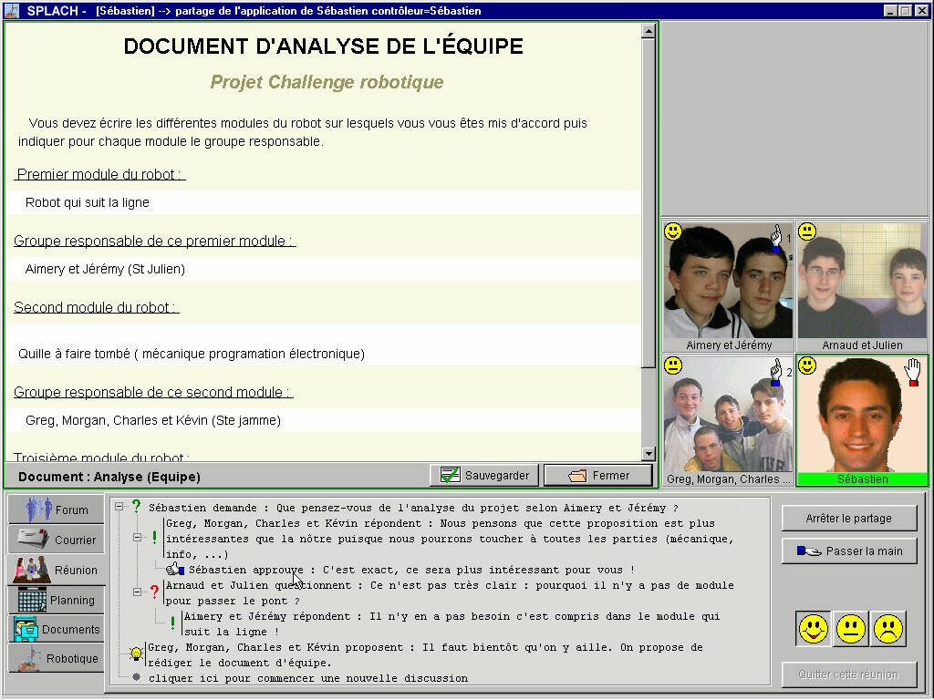
Figure 6: Example of a synchronous meeting with shared screen
From this point onwards, each group was responsible for a specific module of the robot, although of course, the modules were not independent of each other. The students had to work really collectively to bring the modules together as one robot for the competition. At each stage, the learners were asked to fill in the documents explaining the work done on their respective modules, including diagrams or photos if necessary (Figure 7). The students were then aware of the designs for the other parts of the robot and could ask questions.
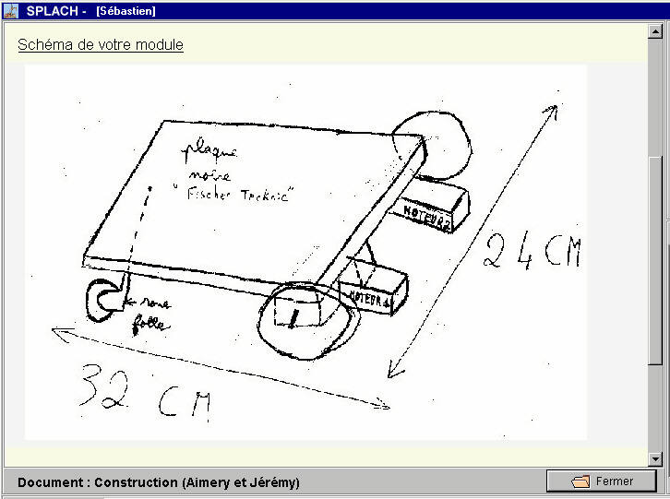
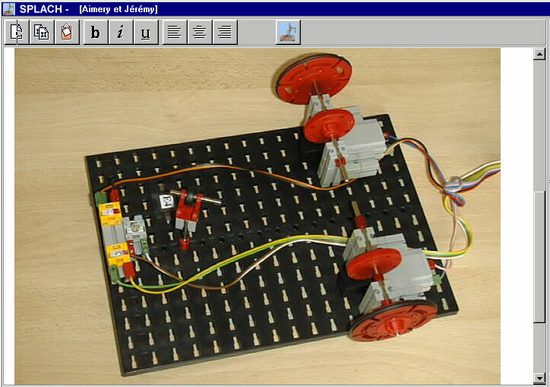
Figure 7: Examples of documents containing diagrams and photos
Not all the stages of the projects are detailed here, as subsequent stages unfolded in much the same way as the first with a succession of asynchronous phases (working on the modules of the robots and writing group documents) and synchronous phases (team discussion and writing team documents). Moreover, the students had the possibility to access to any gear remotely so as to do some tests.
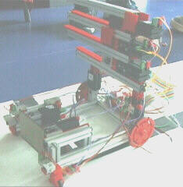
Two weeks before the end of the project, the students met physically for the first time in order to assemble the different parts of the robot. It was done quite quickly, in about two hours (Figure 8). The students also designed the main program to drive the robot from the various programs they had written.
Module to knock down the skittle
Module to follow the line
Module to put the ball in the hole
Figure 8: Integration of the modules of the robot
On the day of the competition the robots were ready at last, and one of the teams was even joint winner of the challenge.

Results of the experiment
This experiment has shown that it is possible to use project-based learning in a distance learning context. Indeed, the aim of the projects has been achieved, that is to say, in our case, the collective construction of robots. Moreover a questionnaire filled out by the learners after the experiment shows how they felt the need to work collectively, and that they found this collective work highly motivating. The same questionnaire also shows that the learners had the feeling they were part of a team throughout the project, and this was apparent during the competition. We can therefore say that our main educational aim, which was to create social cohesion between distance learners, has been achieved.
This experiment also made it possible to substantiate the validity of the SPLACH environment from both functional and technical points of view. This environment is capable of supporting distant project-based learning. The students found it easy to use, supposedly because it integrates all the tools necessary for collective activity. Furthermore, structuring the project in stages gave it continuity and helped the learners to schedule their activities.
We did notice, however, that each of the two teams had a different level in both quality and quantity of interactivity during the experiment, as one team had less discussion, negotiation and confrontation than the other. This can be explained by a problem of organization within the team. Initially all the schools concerned had decided to set aside the Friday lunchtime slot for synchronous meetings, but variations in the students’ timetables and canteen services meant that the groups could seldom meet at the same time for the synchronous phases. Their work was mainly asynchronous, the effect of which was that each group concentrated on their own module and did not communicate very much with the others. In the team where there was more interactivity, one group was particularly active, and this had a catalytic effect. It was, moreover, this team which obtained the best result on the day of the competition. Our research work will now be directed towards designing a system to offer advice adapted to the individual workings of each team.

Conclusions and futures directions
In this paper we have shown that project-based learning is particularly well adapted to a collective distance learning situation. We have presented the implementation of this pedagogical method in the form of collective work between learners leading to the common design of an end-product. The learners formed a team to work on a project defined by a list of specifications, to be split into interdependent sub-projects which they then shared between themselves, while making sure their respective work was coordinated so that the various parts could be integrated at the end. We have described an experiment involving such a collective learner project in the field of educational robotics.
As regards learning about project methodology and collective work in general, human organization, structuring the project in stages where the necessary progression from one stage to the next gives the project continuity and writing work documents in groups or in teams – all these things contribute to the learners’ feeling of living a real-life project, and make them aware that everyone has a role to play (project leader and other team members), that communication with the others is necessary to explain their individual work and to reach agreement in order to achieve a common production, and that they need to schedule and be responsible for carrying out their tasks within the team.
Of course the computer environment used to support project-based learning plays an important part. In this paper we have shown how the SPLACH environment can be used as a support for educational robotics, but it was in fact designed to support any type of project. This first experiment has proven the validity of this environment from a functional point of view. We now wish to carry out a new experiment, in another context, with students studying programming in Quebec. Another future direction of our work lies in assisting collective activity from the data analysis of learners’ activities.

Acknoledgements
We would like to thank the France/Quebec cooperation commission for their support. It is realized inside the LEA project concerned by the tele-assistance in the context of practical work in technology. The LEA team is composed of researchers from the LIUM (France) and the LICEF (Quebec).
The authors also wish to express gratitude to the schoolteachers and their students for enabling us to carry out the experiment in a real-life situation.

Notes
¹ SPLACH is the French acronym for “Support d’une pédagogie de Projet pour L’Apprentissage Collectif Humain” which can be translated as “Support Project-Based Learning for Collective Human Learning”.

References
[Bruner 1998] Jerome Bruner, L'approche psycho-culturelle de l'éducation, 4ème biennale de l'éducation et de la formation, La Sorbonne, Paris, France, (1998).
[Derycke 1991] Alain Derycke, Hypermédia et apprentissage coopératif, B. De La Passardière, G. L. Baron, (Eds.), Actes des premières journées scientifiques Hypermédias et Apprentissages, Châtenay-Malabry, France, (MASI-INRP, 1991), p. 77-87.
[Dewey 1902] John Dewey, The Child and The Curriculum (Chicago: University of Chicago Press, 1902).
[Freinet 1977] Célestin Freinet, Les Techniques Freinet de l'école moderne. Bourrelier, Ed., Carnet de pédagogie pratique (librairie Armand Colin, 1977).
[Goguelin 1994] Pierre Goguelin, Aider chacun à devenir l'auteur de son propre projet, Dossier Projet, Sciences Humaines, vol. 39 (mai 1994), p. 31, (1994).
[Jermann and Dillenbourg 1999] Patrick Jermann, Pierre Dillenbourg, An analysis of learner arguments in a collective learning environment, C. Hoadley, (Ed.), Computer Supported Collaborative Learning (CSCL'99), Stanford, Menlo Park, CA, (1999), p. 265-273.
[Johnson and Johnson 1991] Roger T. Johnson, David W. Johnson, Learning together and alone, Cooperative, Competitive and Individualistic learning (Englewood Cliffs : Prentice Hall, 1991).
[Kilpatrick 1918] William Heart Kilpatrick, The Project Method, Teachers College Record, vol. 19 (2), p. 319-335, (1918).
[Legrand 1986] Louis Legrand, Pédagogie de projet, projet technique, Bulletin de l'Association des Enseignants Activités Technologiques (AEAT), vol. 65 (3ème trimestre), (1986).
[Leroux et al. 1996] Pascal Leroux, Martial Vivet, Patrick Brézillon, Cooperation between Humans and a Pedagogical Assistant in a Learning Environment, Proceedings of European Conference in AI in Education (EuroAIED), Lisbon, Portugal, (1996), p. 379-385.
[Paquette and Ricciardi-Rigault 1997] Gilbert Paquette, Claude Ricciardi-Rigault, Le Campus Virtuel : un réseau d'acteurs et de ressources, Revue de l'Association canadienne d'éducation à distance, vol. XII (1/2), p. 85-101, (1997).
[Polman 1996] Joseph Polman, Bootstrapping a Community of Practice: Learning Science by Doing Projects in a High School Classroom, D. C. Edelson, E. A. Domeshek, (Eds.), International Conference on the Learning Sciences, Charlottesville, VA, (1996), p. 474-479.
[Repenning et al. 1998] Alexander Repenning, Andri Ioannidou, James Ambach, Learn to Communicate and Communicate to Learn, Journal of Interactive Media in Education, vol. 7, (1998).
[Scardamalia and Bereiter 1994] Marlene Scardamalia, Carl Bereiter, Computer Support for Knowledge-Building Communities, The Journal of Learning Science, vol. 3 (3), p. 265-283, (1994).
[Sherry 1996] Lorraine Sherry, Supporting a Networked Community of Learners, Tech Trends, vol. 41 (5), p. 28-32, (1996).
[Vivet et al. 1993] Martial Vivet, Pascal Leroux, Olivier Hubert, J. Morandeau, C. Parmentier, Teleassistance of Trainees in an SME: A Case Study, IFIP TC3 Third Teleteaching Conference, Trondheim, Norway, (1993), p. 907-914.
[Wenger 1998] Etienne Wenger, Communities of Practice, Learning as a Social System, Systems Thinker, (1998).

