Computer-supported collaboration in argumentative writing

Gijsbert Erkens, Jos Jaspers, Hermina (Tabachneck-)Schijf & Maaike Prangsma

Department of Educational Sciences
Utrecht University,
Heidelberglaan 2,
NL-3584CS Utrecht,
The Netherlands

Abstract
In the COSAR-project a computer-supported collaborative learning environment enables students to collaborate in writing an argumentative essay. The basic TC3-groupware environment (TC3: Text Composer, Computer supported & Collaborative) offers access to relevant information sources, a private notepad, a chat facility including a chat history, and a shared word-processor. The control group – 38 pairs of high school students – completed one or two essays per pair in the basic TC3 environment, all anonymously graded by their teacher. We analyzed the logged discussion (‘chats’) and activity protocols for task-related processes present during discussion and collaboration. Processes looked into are planning, gathering information and composing the essay, as well as collaborative processes such as coordinating turn taking and time management. A total of 49 protocols were analyzed. The final essays were analyzed on quality of the structure, and quality of local and overall argumentation. Our main research question is how task-related planning activities and collaborative coordination relate to the quality of the resulting argumentative texts. We found that coordination and discussion of specific content of goals, knowledge and formulating text have a positive influence on the argumentative quality of the texts. Overall coordination and planning of the writing activities on a meta-level seems less important for the quality of the text. For further research, planning tools for writing – a shared concept mapping tool for content generation and a shared outline facility for content linearization – will be added to the basic TC3 environment.

Computer Supported Collaborative Writing

A recent Dutch educational law has transformed the program of the final three years of college preparatory high school. Among others, schools are required to provide support for students to do increasingly independent research, in order to prepare them better for university studies. Working and learning actively, constructively and collaboratively are seen as important elements of this curriculum. The computer-supported collaborative writing environment developed in the COSAR project fits well within this new program, as the active and interactive nature of the Information and Communication Technology (ICT) involved emphasizes both the constructivist and collaborative aspects.
Computer- and telematics-based environments offer a wide variety of possibilities, which makes them especially suitable for collaborative learning: they integrate multimedia information sources, data processing tools and systems of communication (time and place independent) into one single working environment (Bannon, 1995, Van der Linden, Erkens, Schmidt & Renshaw, 2000). Computer Supported Collaborative Learning systems (CSCL) are assumed to have the potential to enhance the effectiveness of peer learning interaction (Dillenbourg, 1999). The collaborative aspect is mainly realized by offering computerized tools that can be helpful for solving the task at hand (e.g. the CSILE-program of Scardamalia, Bereiter & Lamon, 1994; the Belvèdere program of Suthers, Weiner, Connelly & Paolucci, 1995). These tools are generally one of two types: task related or communicative. Task-related tools support the performance of the task and the problem-solving process (Teasley & Rochelle, 1993; Salomon, 1993). Communicative tools give access to collaborating partners, but also to other resources like external experts or other information sources via the Internet (Henri, 1995). Programs that integrate both functions are generally known as groupware: programs that are meant to support collaborative group work by sharing tools and resources between group members and by enabling communication within the group and with the external world.
In computer-supported collaborative writing, as yet not much is known about the relation between collaboration processes, writing strategies and use of the computer environment as a tool. We are interested in finding out how collaborative processes and writing strategies influence the final product within a computer environment. One question we want to answer is whether writing strategies discussed in the collaboration protocol accurately reflect the writing strategies used and how these relate to the quality of the final product.

Planning activities in argumentative writing
Theories of writing (Hayes & Nash, 1996) generally distinguish three types of activities in the writing process: planning (generating, organizing and linearizing content), formulating or translating (writing the text) and revising. Planning an argumentative text is a task for generating and ordering arguments based on one’s own position and the audience’s needs. Furthermore, the writer must solve the rhetorical problem of convincing the audience of the merit of the position taken. Unlike storytelling, the order of the content of an argumentative text does not inherently follow from the order in which events take place. During planning activities, ideas will probably be conceived and organized at a very different level – for instance, in argument clusters. Hence, linearization of contents is needed before the ideas can be turned into text, and again when a text is re-organized. Linearization, therefore, is an important part of argumentative writing (Coirier, Andriessen & Chanquoy, 1999). It appears that converting the conceptual representation of ideas into linear text is a crucial problem for writers of argumentative texts.
Much prior research has been concerned with preplanning. Preplanning refers to planning activities that occur before the actual writing of the text. Research has shown that preplanning can have a favorable effect on the quality of the text. It turns out that inexperienced writers seldom do preplanning (Alarmargot, 1997). Moreover, because of a lack of knowledge of the issues involved, when preplanning does occur in children it is more likely to be a superficial sort of brainstorming, which is actually not much more than simple content-activation based on the terms used in the assignment (Bereiter & Scardamalia, 1987). Torrance, Thomas, & Robinson (1996) likewise found little idea generation based on rhetorical demands during preplanning for adult undergraduates. Rather, their idea generation made a better match with a simple content-activation model. Also, the number and originality of ideas in the draft were not correlated with time spent preplanning.
Lacking preplanning skills, support of online planning becomes especially important for inexperienced writers. Online planning denotes the monitoring activities that occur during writing based on set goals, ideas, expectations and strategies (Van der Pool, 1995). These activities direct the process of knowledge construction during writing. Online planning activities, unlike preplanning, are generally linked more strongly to the local organization of the text. Preplanning, at least in experts, is concerned more with global issues like setting goals and determining overall organization and genre. In prior research, the transition between preplanning processes and writing the actual text was found to be a stumbling block. Kozma (1991) and Bereiter and Scardamalia (1987) found positive effects of teaching preplanning on the amount and/or the quality of preplanning, but not on the quality of the written text. The problem may lie in the transitional processes of linearization and translation.
In collaborative writing, reflecting on such transitions becomes a natural process. In writing a shared text, the partners will have to agree on both the content and the organization of the text. In addition, the use of resources will have to be discussed and coordinated. The constructive activities of organizing, linearizing and translating to the common text will have to take place in mutual deliberation, necessitating verbalization of ideas. This negotiation, resulting in shared knowledge construction, takes place in the collaboration dialogue between the partners (Andriessen, Erkens, Peters & Roelofs, submitted). A larger amount of mutual coordinating activities in the dialogue is expected to result in a more consistent shared knowledge structure and in better mutual problem solution, i.e., a better argumentative text (also see Baker, 1999). Furthermore, computer support for content generation, organization and linearization will help to make these planning activities explicit and negotiable.

The COSAR project
In the COSAR project (COmputer Supported ARgumentative writing) we study electronic collaborative text production regarding the relation between characteristics of interaction on the one hand and learning and problem solving on the other (http://owkweb.fss.uu.nl/cosar). A groupware program (TC3: Text Composer, Computer Supported & Collaborative) has been developed that combines a shared word-processor, chat-boxes and private access to internal and external information resources to facilitate collaborative distance writing. The program is meant for pairs of students (16-18 year old) working together on argumentative essays based on provided information resources, within the context of the Dutch language curriculum. The assignment is to choose a position pro or contra a current topic (cloning or organ donation) and to write a convincing text addressed to the Department of Welfare, Public Health and Culture. The information resources provided are recent articles and commentaries from Dutch quality newspapers. The texts should count 600 – 1,000 words and are graded anonymously by the students’ own teachers. Each partner works at his/her own computer and, wherever possible, partners are seated in different classrooms. The window of the basic program displays several private and shared windows.
The basic environment consists of four main windows (see Figure 1):
- INFORMATION (upper right): The assignment, relevant information sources and TC3 operating instructions can be accessed in a tabbed window. Sources are divided evenly over the partners.
- NOTES (upper left): A notepad in which each student can make private, non-shared notes.
- CHAT (lower left): The lower chat box shows the student’s current contribution, the one above it shows the incoming messages of his partner (WYSIWIS: What You See Is What I See). The scrollable window shows the discussion history.
- SHARED TEXT (lower right): A shared word-processor (also WYSIWIS) in which the common text can be composed by taking turns.
Two planning tools will be added to the basic TC3 environment:
- DIAGRAMMER: Tool for generating, organizing and relating information-units in a concept map. With the diagrammer the students can make a graphical summary of the paper.
- OUTLINER: Tool for linearizing content in a text outline structure, similar to a table of contents.
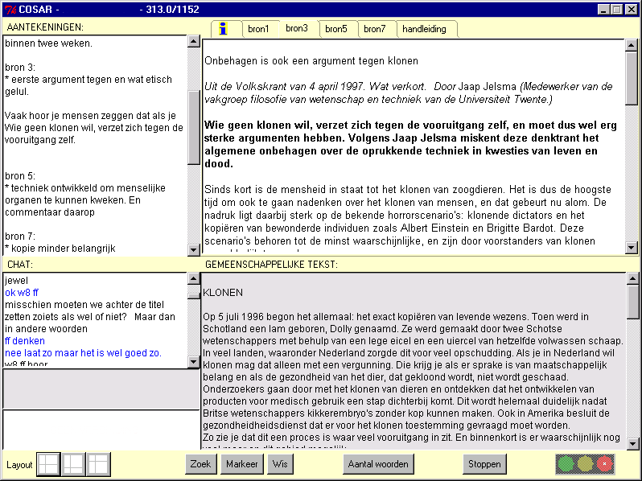

Figure 1. Screen dump of the collaborative writing environment TC3

In the first study, pairs of students from two college preparatory highschools wrote one or two argumentative texts on the topics cloning and organ donation in the basic TC3 environment. The evaluation by the students showed that, although criticizing technical flaws and drawbacks of the program (mainly in the first session), they were rather enthusiastic about this way of computer-supported collaborative learning. In a second study we will experimentally introduce the planning tools in order to determine their effect on the argumentation in the discussion and the resulting essay. In this paper, we discuss the results for three research questions in the context of the first study in the COSAR project:
- Which types of writing strategies do the students discuss during collaboration?
- Is the argumentative quality of the texts related to the type of writing strategies discussed?
- Do writing strategies differ in phases of writing for high, medium and low achieving pairs?

Method of Analysis

Chat discussion protocols
The effort of protocol analysis was reduced by using a computer-supported program, MEPA (Multiple Episode Protocol Analysis), developed at Utrecht University. The purpose of MEPA is to offer a flexible environment for creating protocols from verbal and non-verbal observational data, and for annotating, coding and analyzing these. The chat discussions and the essays were coded in MEPA on several dimensions. The chat utterances were coded for dialogue-acts and task-acts. These two dimensions represent the communicative and task content levels in the discourse. In this paper we discuss results on the task content level only, as they refer to the students’ writing strategies used for writing the essays.

Task-acts: discussion of writing strategy
Task-acts label the task-related content of the utterances. To label the task-acts, the chat message units generated for dialogue-act coding were combined into episodes; each task-related episode received a single coding. A total of 20 task-act categories were distinguished (see Table 1). The three main levels of categorization are planning (meta-cognitive level), formulating (executing level) and non-task (social and technical level). Categories refer to discussion about goals, sources, notes, knowledge, text, layout, revision, turn taking and overall coordination.

Table 1. Task Acts categories (Chat discussion)
Task Acts | Concerning:
Planning | (meta-cognitive level)
PlanLayout | Layout of contents of the argumentative paper
PlanCoordination | Coordinating time and actions
PlanAlternateTurn | Turn taking
PlanGoals | Goals or criteria relating to set task demands: coordinate goals
PlanSource | Using and coordinating use of source material
PlanExternalSource | Using and coordinating use of external source material
PlanKnowledge | Information generated by student: knowledge, ideas & experiences
PlanText | General planning of the text: general approach to writing & global content
PlanNotes | Making and using notes
PlanRevise | Proposing and coordinating revision of the text
Formulating | (content level)
FGoal | Verifying fulfilling of task demands
FCount | Checking the number of words written thus far
FSource | Passing source contents to the other, summarized; discussion of contents
FExternalSource | Passing external source contents to the other, summarized; discussion
FKnowledge | Discussing ideas, opinions, experiences, prior knowledge, etc.
FText | Proposing and discussing additions of specific text
FNotes | Discussing content of notes; passing specific content from the notes
FRevise | Discussing revision of specific text (changes, deletes; not additions)
Non-task | (technical and social level)
NonTaskProgram | Technical aspects of the TC3 program
NonTaskSocial | Not task related; discussing of social matters, small talk

Quality and structure of argumentative texts
The argumentative papers were segmented into meaningful units based on sentences. Sentences including more than one argumentative meaning were subdivided. A total of 10 categories of argumentative function were distinguished: claim, conclusion, solution, support, embedded claim, restriction (put in perspective), refutation, organizer, information and elaboration. After coding, the papers were split into topic-related segments. The papers were then given separate scores for: 1) textual structure (i.e., introduction, body & conclusion); 2) empathy with the reader as audience; 3) quality of the argument in each segment; and 4) the quality of the overall argument. The separate scores were combined into an overall score.

Results

Types of writing strategies discussed
Our first question concerns the types of writing strategies the students discussed in order to coordinate their activities. We were interested in the proportions in the discussion of task acts at different levels: meta-cognitive planning of the text, and discussion on an executive level, that is, about the specific content of the sources, of their knowledge or notes and about the way contents should be written in the shared text. Furthermore, we want to know how much revision of the text was planned or executed in the collaborative discussion.
Table 2 shows the mean percentages and standard deviations for the frequencies of the task-act episodes in the 49 chat protocols. On average, we found that more episodes in the chat dialogues were spent planning (47%) than formulating (36%), and chatting about non-task related items (17%). By far the highest percentage of planning episodes were spent on planning the text (12.7%), even more than formulating the text (9%). After planning the text, planning coordination was the most frequent (9.3%), followed by planning the taking of turns for writing (6.5%). These two are almost pure coordination, having to do little with the content of the text. So, almost 16% of the 47% spent on planning was spent coordinating. The other planning scores, such as planning the use of sources, layout, notes, text and revision also contain high degrees of coordination such as task-division or assigning roles. Planning the use of sources (5.8%) was the next highest category. Relatively few episodes were spent on planning goals, use of one’s own knowledge, revision, use of external sources, layout and use of the notes window.

Table 2. Mean percentages, standard deviation of task–act writing strategies discussed in the chats

Task Acts | Mean | Sd. | (N = 49) | Mean | Sd.
Planning | 46.66 % |  | Formulating | 36.47 %
PlanLayout | 1.69 | 1.47 | Fgoal | 2.77 | 1.45
PlanCoordination | 9.34 | 3.65 | Fcount | 3.80 | 2.30
PlanAlternateTurn | 6.53 | 3.35 | Fsource | 4.55 | 3.01
PlanGoals | 2.04 | 1.58 | FexternalSource | 1.13 | 1.31
PlanSource | 5.81 | 2.60 | Fknowledge | 4.88 | 3.32
PlanExternalSource | .85 | 1.03 | Ftext | 9.01 | 3.66
PlanKnowledge | 2.52 | 1.73 | Fnotes | .41 | .57
PlanText | 12.71 | 3.98 | Frevise | 9.92 | 5.87
PlanNotes | 1.74 | 1.62 | Non-task | 16.85 %
PlanRevise | 3.43 | 1.85 | NonTaskProgram | 3.16 | 1.92
 |  |  | NonTaskSocial | 12.51 | 5.94

For formulating, the highest percentage of episodes was found for revision (9.9%), closely followed by formulating text (9.1%). The next categories were formulating one’s own knowledge (4.9%), formulating knowledge from the supplied sources (4.6%), and tracking the number of words (3.8%). Small percentages of the episodes were spent formulating goals, material from external sources, and private notes.
By far the most episodes, in the non-task category were spent on social talk (12.5%). Students spent 3.2% of the episodes discussing technical features or problems with the TC3 program.
No significant differences were found between schools in the distribution of types of writing strategies in the chat protocols. Moreover, no differences were found in writing strategies for the two topics (cloning and organ donation). No differences were found between boys’ and girls’ discussed writing strategies.
The argumentative quality of the texts was measured on four levels: textual structure, audience, mean argumentative structure in text segments and overall argumentative structure of the text (all normalized on a 1-10 scale). A total argumentative quality score was obtained as the mean of these scores. In general, textual structure and attention to the audience scored highest (6.8 & 6.2). The argumentative structures in the overall text and in text segments had a lower mean score (5.6 & 6.0). No significant correlation of our scoring system with the grading system of the teachers (blind graded) was found, due to the different criteria (style and spelling) the teachers used in addition to the argumentative features of the texts. On the basis of the argumentative quality of the essays, the pairs were divided into high, medium and low achievement groups (0 – 5.5 low; 5.5 – 7 medium; and > 7 high), a common division in Dutch school grading systems. Each group included about a third of the pairs.

Relation of discussed writing strategies with argumentative quality of the text
The second research question is concerned with the relation between types of writing strategies discussed and the quality and argumentative structure of the resulting text. We expected to find that a higher frequency of mutual coordinating activities in the dialogue results in a better argumentative text. Most of the coordinating activities were categorized as different types of planning. Thus, students who write better papers were expected to do more meta-cognitive planning. We had no explicit expectations on the executing level, although more discussion on formulating the text, contents of knowledge and information sources was expected to lead to higher quality of the specific contents discussed. As far as non-task behavior was concerned, it was expected that the high achieving pairs would focus more on the task and exhibit less non-task behavior.

Table 3. Pearson correlations between task–acts % and quality measures of argumentative texts
Task Acts % X Text scores | Textual structure | Audience score | Segment score | Argumentation score | Mean score
Planning
PlanLayout | .103 | -.082 | -.102 | -.077 | -.066
PlanCoordination | -.106 | -.254 | -.250 | -.080 | -.202
PlanAlternateTurn | -.135 | .030 | -.200 | -.072 | -.101
PlanGoals | .026 | -.083 | .007 | -.038 | -.036
PlanSource | -.067 | -.152 | -.243 | -.231 | -.227
PlanExternalSource | -.111 | .072 | .205 | -.065 | .025
Planknowledge | -.012 | .043 | .244 | .067 | .104
PlanText | .050 | .178 | .143 | -.046 | .084
PlanNotes | .015 | -.150 | -.113 | .043 | -.056
PlanRevise | -.096 | .161 | .214 | .048 | .109

Formulating
Fgoal | .060 | .336* | .172 | .163 | .237
Fcount | -.032 | -.134 | -.173 | -.051 | -.117
Fsource | .013 | .003 | -.008 | -.034 | -.013
FexternalSource | -.019 | .002 | .114 | .080 | .062
Fknowledge | .273 | .391* | .234 | .229 | .341*
Ftext | .146 | .297* | .372** | .211 | .314*
Fnotes | -.180 | -.023 | -.088 | .013 | -.060
Frevise | .112 | .134 | .213 | .138 | .181

Non-task
NonTaskProgram | -.082 | -.283* | -.248 | -.097 | -.214
NonTaskSocial | -.195 | -.375** | -.355* | -.187 | -.334*
N= 49; significance: grayed: ** : p < .01; * : p < .05; p < .10

Table 3 shows the Pearson correlations between percentages of task-acts and text quality scores. Contrary to our expectations, discussing planning activities on a meta-cognitive level is not generally linked with the quality of the resulting text. Only a few significant correlations were found. More frequent discussion of general coordination matters (PCoordination) is in fact negatively correlated with – and so leads to lower scores for – audience directedness and the argumentative structure in the text segments. Planning for finding information in the sources (PSource) is also negatively correlated with these measures. Only planning the use of one’s own knowledge and ideas (PKnow) – i.e. inquiring after the partner’s opinions and ideas about the topic – leads to better argumentative structure in the text segments.
On the executing level, however, positive correlations were found. More specific discussion of the goal of the assignment (FGoal) results in better audience directed texts. Discussion of specific content of one’s own ideas and knowledge and those of one’s partner (FKnow) leads to texts with better argumentative quality on all scores, especially on textual structure and audience directedness. In addition, discussion of formulating specific content in the text (FText) correlates with a higher level of audience directedness and better argumentative structures in the text segments. Asking and talking about specific information in the sources (FSource & FExternalSource) does not influence the quality of the text produced.
Discussion of text revision, on a planning as well as on a formulating level, does not clearly correlate with the quality of the text, although a small positive (not significant) correlation with the argumentative quality of segments was found.As expected, discussion of non-task matters, such as the computer program itself or social talk, were negatively correlated with the quality of the resulting text. More frequent non-task chat resulted in lower scores for audience directedness and argumentative structure in the text segments.

Differences in writing strategies in phases of the writing process
The third question concerns the writing strategy differences between high, medium and low achieving pairs in different phases of the writing process. We were interested to find out whether there were such differences, and whether better developed preplanning skills led to better texts.
The bar charts in Figure 2 depict percentages of planning, formulating and non-task activities in three phases of collaborative writing for low, medium and high performance groups. There are two points in time in the writing process that can be clearly distinguished: the first draft and the final draft. We have used these as anchors. In between, one or more drafts are written. The middle draft is the text at the interval time between the first and final drafts. The first phase refers to the chat before writing the first draft, and so reflects the pre-planning phase. The second phase is between the first draft and the middle draft. The third phase is from the middle draft up to the final draft.
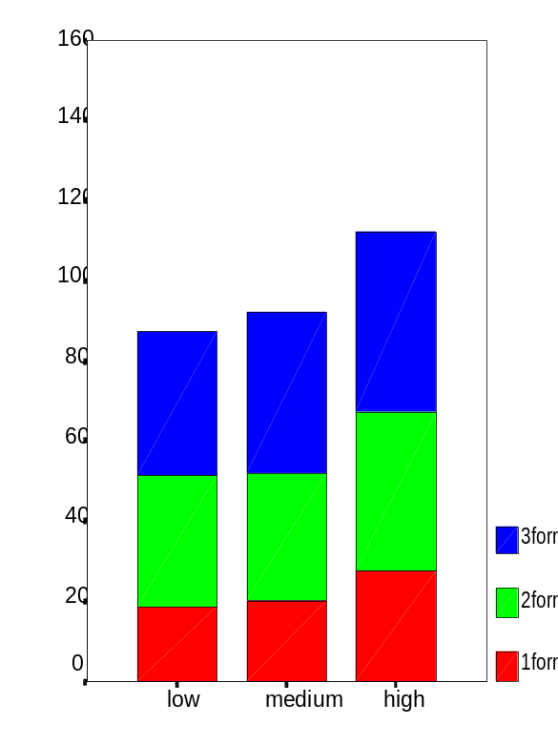
The charts show that planning activities on a meta-level occur in all three phases in equal proportions, and not just in the first “pre-planning” phase. Furthermore, they show that planning is about the same for all three performance groups. Formulating, however, clearly occurs more often in the high achieving group. Formulating specific content is less apparent in the first phase of the writing process. Non-task chat occurs as expected: the higher the performance, the lower the percentage of non-task chat.
Figure 2: Percentages for planning formulating and non-task activities in three phases of collaborative writing in low, medium and high performance groups.

Conclusion

Collaborating students – writing a common argumentative paper together in a computer supported environment – more frequently discuss planning writing activities on a meta-cognitive level than the specific contents of knowledge, goals or the text itself. However, we found that coordinating and discussing specific content of goals, knowledge and formulating text positively influence the argumentative quality of the texts. Overall coordination and planning of the writing activities on a meta-level seems less important for the quality of the text. Planning activities on a meta-level are equally frequent in all three phases of the collaborative writing process for low, medium and high achieving pairs. Discussion of specific content clearly occurs more often in the high achieving groups. Formulating specific content is less apparent in the first phase of the writing process. Furthermore, we found that the higher the performance, the lower the occurrence frequency of non-task chat. On the basis of these results we can conclude that shared knowledge construction, coordination in discussing knowledge on a meta-cognitive as well as on a specific content level, is an essential part of collaborative text writing. Discussing and sharing knowledge result in a higher argumentative quality of the text.

References
Alamargot, D. (1997). Processes de recuperation et d'organisation dans l'activite de redaction de texte. Effet de l'acquisition des connaissances referentielles. These Doctorat de Psychologie. Université de Poitiers.
Andriessen, J.E.B., Erkens, G., Peters, N., & Roelofs, E. (submitted) Interaction and performance in computer supported collaborative tasks. To appear in H. Oostendorp, Cognition in a Digital World. Hillsdale, NJ: Lawrence Erlbaum Associates
Baker, M. (1999) Argumentation and constructive interaction. In J.E.B. Andriessen & P. Coirier (Eds.) Foundations of Argumentative Text Processing (pp.179-203). Amsterdam: University Press.
Bannon, L.J. (1995). Issues in Computer Supported Collaborative Learning. In C. O'Malley (Ed.), Computer Supported Collaborative Learning (pp. 267-283). NATO ASI Series, Vol. 128, Berlin Heidelberg: Springer-Verlag.
Bereiter, C., & Scardamalia, M. (1987). The psychology of written composition. Hillsdale, NJ: Lawrence Erlbaum Ass.
Coirier, P., Andriessen, J.E.B., & Chanquoy, L. (1999). From planning to translating: The specificity of argumentative writing. In J.E.B. Andriessen and P. Coirier (Eds.), Foundations of argumentative text processing (pp 1-29) Amsterdam: Amsterdam University Press.
Dillenbourg, P. (1999). Introduction: what do you mean by "Collaborative Learning"? In P. Dillenbourg (Ed.), Collaborative Learning: Cognitive and computational aspects (pp. 1-19). New York: Pergamon.
Hayes, J.R., & Nash, J.G. (1996). On the nature of planning in writing. In C.M. Levy & S. Ransdell (Eds.), The Science of Writing (pp.29-55). Mahwah, NJ : Lawrence Erlbaum Associates.
Henri, F. (1995). Distance learning and computer mediated communication: Interactive, quasi-interactive or monologue? In C. O'Malley (Ed.), Computer supported collaborative learning (pp. 145-165). NATO ASI Series, Vol. 128. Berlin: Springer.
Kozma, R.B. (1991). The impact of computer-based tools and embedded prompts on writing processes and products of novice and advanced college writers. Cognition and Instruction, 8, 1-27.
Salomon, G. (1993). On the nature of pedagogic computer tools: The case of the writing partner. In Lajoie, S.P. and Derry, S.J.(Eds.) Computers as Cognitive Tools (pp. 289-317). Hillsdale, NJ: Lawrence Erlbaum Associates.
Scardamalia, M., Bereiter, C., & Lamon, M (1994). The CSILE Project: Trying to Bring the Classroom into World 3. In K. McGilly (Ed.), Classroom Lessons: Integrating Cognitive Theory and Classroom Practice (pp. 201-229). Cambridge, Massachusetts: The MIT Press.
Suthers, D., Weiner, A., Connelly, J., & Paolucci, M. (1995). Belvedere: Engaging students in critical discussion of science and public policy issues. In Greer, J. (Ed.). Artificial Intelligence in Education (pp. 266-273). Charlottesville: AACE.
Teasley, S., & Rochelle, J. (1993). Constructing a joint problem space: The computer as tool for sharing knowledge. In S.P. Lajoie & S.J. Derry (Eds.) Computers as Cognitive Tools (pp. 229-257). Hillsdale, NJ: Lawrence Erlbaum Associates.
Torrance, M., Thomas, G.V. & Robinson, E.J. (1996). Finding something to write about: strategic and automatic processes in idea generation. In C.M. Levy & S. Ransdell (Eds.) The Science of Writing (Pp 189-205). Mahwah, NJ: Lawrence Erlbaum Associates.
Van den Bergh, H. & Rijlaarsdam, G. (1999). The dynamics of idea generation during writing: an on-lne study. In: M. Torrance & D. Galbraith (Eds.), Knowing what to write: conceptual processes in Text Production (pp. 99-120). Amsterdam: Amsterdam University Press.
Van der Linden, J.L., Erkens, G., Schmidt, H. & Renshaw, P. (2000). Collaborative learning. In: P.R.J Simons, J.L. van der Linden and T. Duffy (Eds.). New Learning (pp 37-55). Kluwer Academic Publisher.
Van der Pool, E. (1995). Writing as a conceptual process: a text-analytical study of developmental aspects. PhD-thesis, Catholic University Brabant, Netherlands.

With thanks to Joyce van Berlo, student assistant, for her work in coding and analysing chat discussion protocols.

