A Digital Library-Based Recommendation Service for Multimedia Development in a Learning Community

Robert B. Allen
College of Information Studies, University of Maryland

Wiwat Puntai
College of Information Studies, University of Maryland
Abstract:
We describe new services that help members of the Maryland Electronic Learning Community (MELC) develop lesson plans with resources from a multimedia digital library. The MELC library now has 6200 multimedia resources. While teachers can search for interesting materials, we have found that they often prefer to share materials used by their colleagues. The new digital library services facilitate this type of social sharing of resources. In particular, we created open electronic bookshelves on which teachers can keep pointers to resources of interest to them and which can also be viewed by other teachers. Furthermore, we implemented the Peer Preference Views interface that lets teachers see summaries of the resources being used by other teachers.
Keywords: digital libraries, learning communities, multimedia, professional development, recommender systems, social representations

MELC Digital Library
The Maryland Electronic Community (MELC), a part of the Baltimore Learning Community (BLC), investigates how the professional development of teachers can be supported with information technology. One focus of the project has been the creation, maintenance, and cultivation of a digital library for teachers from five middle schools in the Baltimore area. Currently, the MELC digital library has approximately 6,200 titles of text documents, audio files, video segments, still images, and Web sites covering social studies, science areas, mathematics and language arts. There are public domain items from the National Archives and NASA; proprietary items that have been contributed by project partners Discovery Communications and Maryland Public Television; and personal contributions from MELC members themselves. Each resource is identified by a set of standard metadata elements and then indexed according to Topic, Subtopic, and Standard (corresponding to national standards). Recently, we developed the Quick Indexing Tool (QIT) (Semple et al., 2000) which is a Web-based indexing template that allows teacher members to index educational materials of their interest and submitted it to the library collections.
In addition to providing access to multimedia educational resources, we are equally concerned about how teachers interact with each other and how the services interoperate. We are trying to build a virtual community in which members cooperate and learn from one another how MELC educational resources can be used effectively. In part, we do this by providing multiple channels of communication for the teachers (Rose et al., 1999). The communication channels include a threaded discussion group (MELC-chat), video conferencing (Distance Learning Laboratories), and summer in person training sessions in the summer.

Supporting Communities with Information Technology
We would like to find ways of more closely linking the MELC Digital Library with the MELC Learning Community. This is consistent with Ackerman’s (1996) claims that networking technology, could transform the way in which our society stores and disseminates knowledge. Communication technology will blur the boundary between informal and formal communication channels. Brought together in a virtual community, people will engage in a wide range of activities that serve the purposes of acquiring, creating and exchanging information. In an electronic environment, people not only search for information from a digital library collection; with support from communication technology, they can also seek for the information tailored to their specific concerns by posting a request to other members of the user community. Thus, for information seeking and community, though traditionally thought of as distinct channels of communication, will not strictly remain so in a computer-mediated environment.
In this spirit we feel that there should be a synergy between a digital library and the community it supports. We have observed that teachers like to use resources that they have heard about from other teachers. We develop tools to facilitate this type of interaction. We have previously described (Semple, et al., 2000) tools that allow individuals to annotate resources. In this paper, we describe systems that provide information about use of the resources by other teachers.
These tools may be considered recommendation services. At least three types of recommendation services can be identified. The first is passive. If users make annotations on the documents in the collection, these annotations can be viewed by others who are browsing the collection. Users learn about document from other user's comments thus saving the effort of assessing these documents directly. In the second type of recommendation service, users forward the pointers for information resources the feel would be of interest to a targeted user. This approach is illustrated by Information Lens (Malone et al., 1986) and Tapestry (Terry, 1993). In the third type of recommendation service, the users rate their own interest in the material. These ratings form social representations, which are matched with the ratings made by the user who is seeking the information resource (Allen, 1997, forthcoming).
Our tools help teachers to manage their own information resources on ``bookshelves’’. We assume that the resources on the bookshelves are of interest to the owners of those bookshelves and we allow other teachers to view summaries of the bookshelves of others teachers. In other words, we treat the bookshelves as a type of social representation.

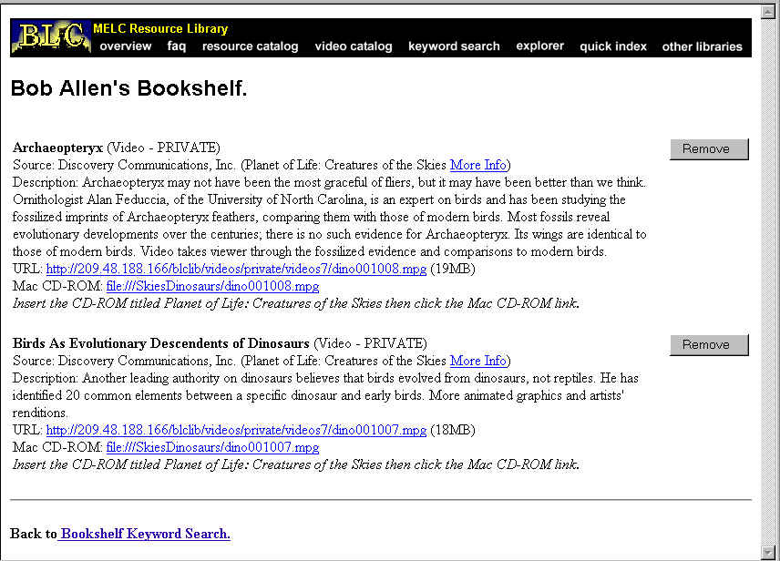
Figure 1: Personal Bookshelf.

Personal Bookshelf
Digital libraries allow resources to be readily integrated with services (e.g., Cousins, et al. 1995). As shown in Figure 1, we have implemented bookshelves to help the teachers develop lesson plans with the resources from the digital library. When a teacher submits a query and receives a a search feature will allow him/her to store relevant items in a personalized Web page. We call this feature a ''personal bookshelf' because it keeps the resources that teachers plan to use in their teaching activities. With this functionality, teachers do not have to repeat a search to retrieve the items they have considered to be of value.
Although bookshelves contain pointers to resources of the teachers' selection, this is not an issue in a hypertext environment because the full resources are only a click away. This bookshelf service is personalized in the sense that teachers have a full control over the content of their bookshelves. They can add new items or delete existing items from the shelves whenever they want. We require teacher users to enter a password before they can have full access to the Personal Bookshelf and its management functionality. Figure 1 gives an example of a personalized bookshelf that feature stored resources with removal functionality.
Shared Bookshelf View
As a step toward sharing of resources in the community, the Shared Bookshelf View allows teachers to see all bookshelves currently stored in MELC digital library (Figure 2). Access to these bookshelves is provided by means of the owners' names with a hyper-link to the page that displays the items currently therein.
The Shared Bookshelf has privacy issues. Accessing the Shared Bookshelf View in this mode does not require a password mode of access. In traditional libraries, circulation data is usually very confidential. We feel that in some situations, teachers in a learning community should be willing to exchange information about their interests. However, it is possible that the visibility of the Bookshelf to other colleagues can make its owner uncomfortable and constrain the kinds of items that they will keep on the bookshelf. We hope that as we learn more about the reaction of teacher users to these new library services, we will become better aware of the level and the manner in which our user community is willing to share information.
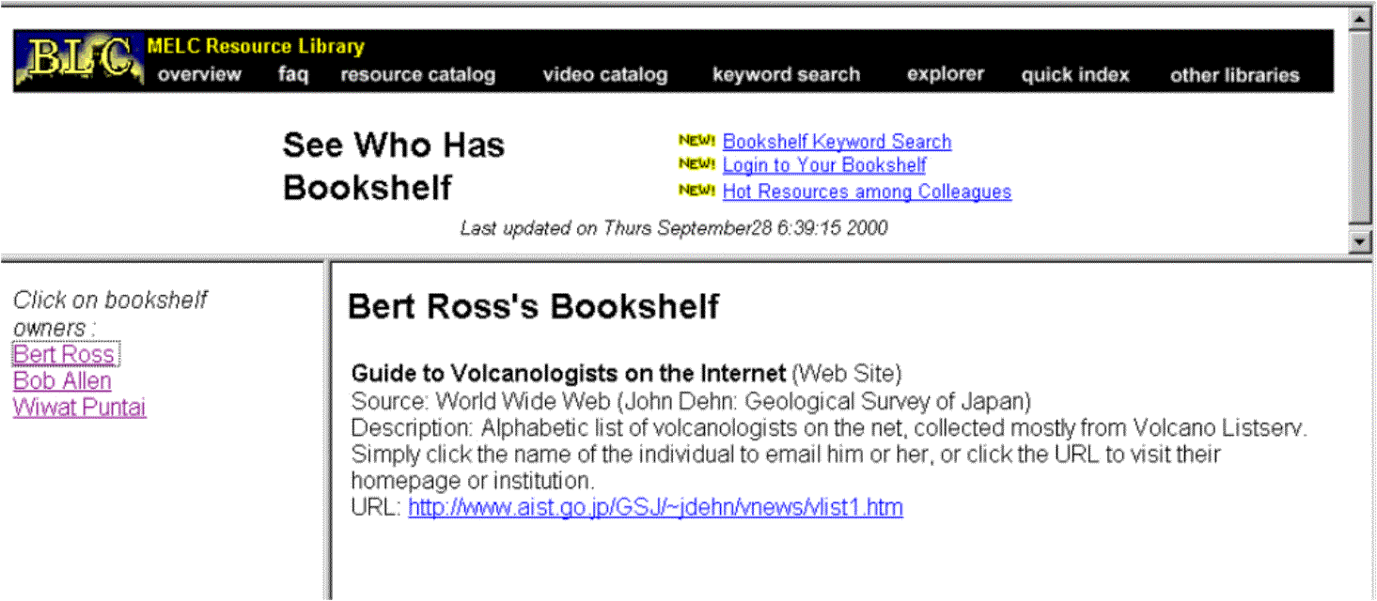
Figure 2: Shared Bookshelf View.

Peer Preference Viewer
From the system's perspective, the bookshelf service provides an alternative information source about library use. In the past, we have relied on transaction logs and records of resource hits. One concern is that these two measures do not accurately reflect the users' preference or opinion. By their nature, they are more records of navigation path and search activities. Some researchers have resorted to the length of time a user spends on a specific document as a surrogate indicator of users' interest (Stevens, 1992). By the same reasoning, we assume that the presence of a resource on a user's Bookshelf reflects that that particular resource is of some value to the user. For the MELC digital library, we give our users direct access to the data about their use of information resources.
Teachers can browse the content of bookshelves by specifying the group of shelf owners. Currently, shelf owners can be defined by three different categories of attributes: subject area, grade, and school. As shown in Figure 3, our interface asks users to check the button corresponding to the specific values of each attribute. In this illustration, if a user requests for a display of all the resources currently stored in the bookshelves of science teachers at Francis Scott Key school.

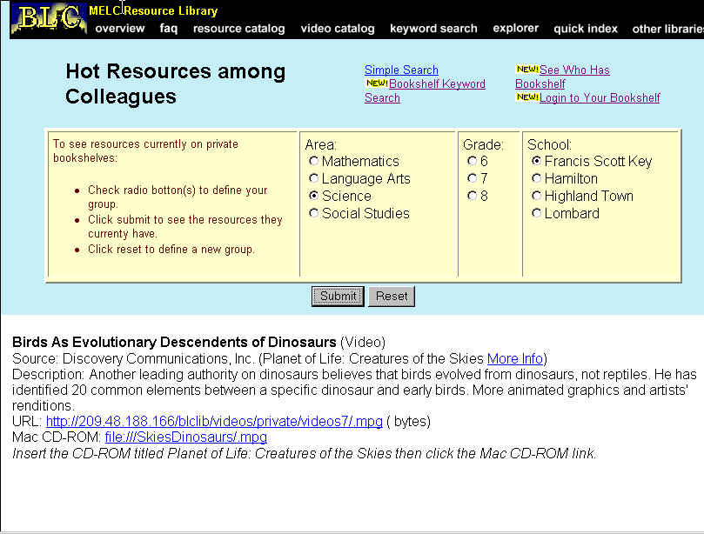
Figure 3: Peer Preference Viewing Interface.
Use Scenario
To illustrate how these new services operate, we describe a projected use scenario by a MELC library teacher-user.

- Bookshelf Keyword Search. While planning a classroom lesson, a teacher goes to the Bookshelf Keyword Search page of MELC digital library to search for relevant instructional materials. The teacher types in a keyword and the search engine returns a list of relevant multimedia documents and then examine them. He/she then assesses the relevance of each document from either elements of document records or if he/she wishes, from the full document by clicking on the hyperlink from within the record.
- Personal Bookshelf: Should he/she decides to store any of the retrieved items for later use, he/she clicks on the button "Add to Bookshelf." The Web-browser redirects him/her to another Web page asking for a login name and a password. When the teacher successfully supplies the user name and password, the system automatically updates and displays his/her personal bookshelf.
- Shared Bookshelf: A teacher may want to browse through the bookshelves of colleagues that he/she is familiar with to get some ideas for the potential resources that he/she may use for a specific lesson plan. By pointing the browser to another page called "See all Bookshelves" (see Figure 2 above), the teacher will be able to see the names of all the teachers who currently have bookshelves. If the teacher clicks on any of the bookshelf owner names in the left frame, the items currently stored on the corresponding bookshelves will be displayed in the main frame on the right.
- Peer Preferences View: A teacher may want to know what instructional resources are currently used by teachers of a certain subject area, grade, or school. With the Peer Preference Viewing Interface (Figure 3), he/she can submit a request by checking the boxes corresponding to the specific values of these three attributes. The database then returns the list of instructional resources used by the specified group. Thus, our system enables a teacher to selectively view the instructional resources that have been indicated as being of interest to his/her colleague users.

Implementation Details
The tools described here are fully operational. The Bookshelf Keyword Search, Personal Bookshelf, Shared Bookshelf, and Peer Preference View have been developed with PERL CGI scripts. The MELC database is implemented in PostgresSQL. In the future, we believe that the library could be more effectively configured as a distributed collection of Open Archives (e.g., Hitchcock, et al., 2000).

Conclusion
We believe that a digital library should be an integral part of the community it supports. Our informal observations suggested that teachers preferred to use resources that were recommended by other teachers. Therefore, we developed new digital library services that facilitate this type of sharing.
While the sharing of resources among teachers is popular, we are concerned that it may not lead to the selection and use of the best possible resources. Some resources may be selected solely on the basis that they were frequently mentioned and not on the basis of merit. We will consider providing feedback about the quality of the resources. For instance, the resources and lesson plans might be judged by expert reviewers. These expert judgments could be used as an indication of quality for the teachers.

Acknowledgments
We thank the Baltimore City Public Schools and the wonderful teachers who are members of the Maryland Electronic Learning Community. We also thank our colleagues at the University of Maryland and partners who are involved in other parts of this effort. In particular, we thank Anne Rose for her consultation on CGI script and the MELC database. A U.S. Department of Education Technology Challenge Grant (#R303A50051) to the Baltimore City Public Schools has supported this work.
References
Ackerman, M. S. (1996). Expertise networks as an enabling technology for cyberspace use. Joint White House PARC Conference on Leveraging Cyberspace. Available at http://www.ics.uci.edu/CORPS/ackerman.html
Allen, R. B. (1997). User models and mental models. In Handbook of Human-Computer Communication (2nd edition), Edited by T. Landauer, M. Hendler, and P. Prabhu, Elsevier, Amsterdam, 49-63.
Allen, R. B. (forthcoming). Information Science and Systems. Oxford University Press.
Bishop, A. P. (1994). The role of computer networks in aerospace engineering. Library Trends, 42,694-729.
Cousins, S. B., Paepke, A., Winograd, T., Bier, E. A., and Pier, K., (1997) The digital library integrated task environment (DLITE). In ACM Digital Libraries, Philadelphia, 142-151.
Hitchcock, S. Carr, L., Jiao, Z., Bergmark, D., Hall, W., Lagoze, C., & Harnad, S. (2000) Developing services for open eprint archives: Globalisation, integration and the impact of links. ACM Conference on Digital Libraries. San Antonio Texas June 2000.
Malone, T. W., Grant, K. R., & Turbak, F. A. (1986). The Information Lens: An Intelligent System for Information Sharing in Organizations. ACM SIGCHI,1-8.
Pea, R. D. & Gomez, L. M. (1992). Distributed multimedia learning environments: Why and How? Interactive Learning Environments, 2(2), 73-109.
Rose, A., Allen, R. B., & Fulton, K. (1999). Multiple channels of electronic communication for building a distributed learning community. Computer-Supported Collaborative Learning, 1999, Palo Alto, 495-502.
Rose, A., Ding, W., Marchionini, G., Beale, J., & Nolet, V. (1998). Building an electronic learning community: From design to implementation. In ACM SIGCHI, 203-210.
Semple, R.P., Allen, R. B., & Rose, A. (2000). Developing an educational multimedia digital library: Content preparation, indexing and usage., Proceedings EdMedia, Montreal, X-X.
Stevens, C. (1992). Automating the creation of information filters. Communications of the ACM. 35, 48.
Terry, D. B. (1993). A tour through Tapestry. Conference on Organizational Computing Systems (ACM COIS/COOCS), Milpitas, CA, 21-30.

Authors' addresses
Robert B. Allen (rba@glue.umd.edu)
College of Information Studies; 4105 Hornbake; University of Maryland; College Park, MD, USA, 20742. Tel: 301-405-2052.
Wiwat Puntai (wpuntai@wam.umd.edu)
College of Information Studies; 4120G Hornbake; University of Maryland; College Park, MD, USA, 20742. Tel: 301-405-8907.

