The Writing’s on the Wall: Large, Remotely Controlled Displays

Mark Ashdown, Peter Robinson
University of Cambridge Computer Laboratory, Pembroke Street, Cambridge CB2 3QG, UK
{msda2, pr}@cl.cam.ac.uk

ABSTRACT
Large display devices are now affordable and desirable in fixed environments such as offices, and scalable methods are available to combine multiple projectors to form such displays with high resolutions. With new input devices, they can facilitate new interaction paradigms. This paper describes the hardware and software of a wall-sized projected display controlled at a distance by a pointing device. The display can replace the monitor and mouse of a computer that uses any of the major operating systems and window systems. Experiences in using it to control a drawing program as a demonstration tool indicate that it is a useful tool for presenting information, especially when the speaker is responding to questions from the audience, and when an audience member wishes to accompany a question with some addition to the existing information. Plans are described to use the technology as part of a collaborative medium that will be tested with a teaching application.

KEYWORDS
Display hardware, large displays, projection, remote desktop.

INTRODUCTION
For decades, the computer has almost exclusively presented a visual interface consisting of a screen with a diagonal measuring 14 to 21 inches and a keyboard and mouse for input. Mark Weiser’s vision of Ubiquitous Computing [15] includes tabs, pads and boards – display and interaction devices of different sizes posing different challenges of implementation and man-machine interface design. The archetypal personal computer has a pad-sized display, but there has recently been much investigation into tab-sized, small-screen technology for users on the move, and as display devices such as LCD and plasma screens and DLP projectors become cheaper and better supported, board-sized displays will become the interface of choice for many users as suitability for the task, rather than technological and economic constraints, becomes the criterion for selecting a display system.

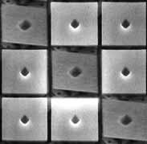
Texas Instruments’ Digital Light Processing (DLP) technology uses, as the basis for a projection system, a Digital Micromirror Device: an array of mirrors built over conventional CMOS SRAM address circuitry (Figure 1)[18]. Currently up to 2.3 million mirrors can be produced on a chip, each being independently able to tilt by ±10 degrees when switched on or off. Such projection systems are now replacing film projectors in cinemas, and large display surfaces using these technologies will become commonplace in the home and office as CRTs are phased out, enabling new applications and providing new challenges for interface design.
Figure 1: 16 µm² mirrors on a Digital Micromirror Device chip

This paper describes related developments that have explored the possibility of large display devices and associated input mechanisms, and then describes this project to create a projected display on the wall that is controlled by a hand-held pointing device. Experiences in using the system for demonstrations by controlling a standard drawing package are reported, and plans are described in which projected desk displays are used as a medium for distributed teaching.

RELATED DEVELOPMENTS
Early work on new interaction paradigms using large displays was undertaken at the Media Room at MIT’s Media Lab. Dataland [3] provided the user with a large 2D graphical space in which to arrange data items such as maps, books, letters, calendars, photographs, motion video pictures and programs like the calculator used in the project. “Put-That-There” [2] explored the combination of voice and gesture in manipulating simple items on the wall of the Media Room. Shapes of various forms and colours could be called into existence, moved about, replicated, have their attributes altered, and ordered to vanish. Pronouns and deictic references could be used, thus if the phrase “Put that there” was uttered, voice recognition software initiated sampling of the pointing direction of the tracker on the user’s finger when the words “that” and “there” were recognised. The selected object was then moved to the specified location.

The LiveBoard [4] was created at Xerox PARC to provide a directly interactive, stylus-based, large-area display. It is a back-projected display, approximately 4 x 3 feet, with a cordless pen that emits an optical beam that is located by a camera behind the screen. The pen can be used to control graphical user interface of programs via a special driver. The most popular LiveBoard programs turned out to be a whiteboard program and a slide show that allowed annotation of the slides.

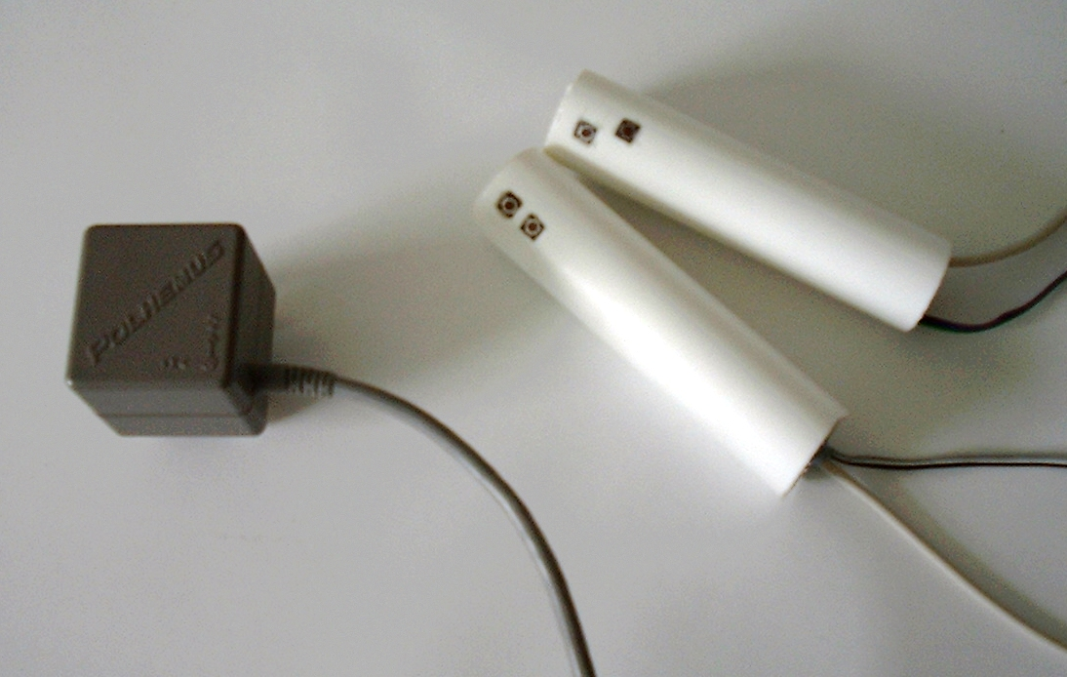
Tivoli is a whiteboard application for the LiveBoard designed to support informal workgroup meetings. It is targeted at meetings where participants work closely together on a problem or idea, rather than at presentations, for example. Interaction with Tivoli prompted reconsideration of many tacit assumptions of traditional GUIs. A pen allows natural gestural input, does not require a cursor, and generates direct position data unlike the relative movements of a mouse that can be scaled to alter sensitivity. A very large interactive surface necessitates careful sizing and positioning of buttons, menus and pop-up messages, and places emphasis on keeping user control at the pen through techniques like gestural commands. Work on Tivoli has continued, with emphasis on the structure and manipulation of object-oriented data.
Figure 2: The magnetic transmitter (left) produces a field that is detected by the receivers in the crayons (right)

The i-LAND project at the German National Research Centre for IT [11] and the iRoom at Stanford [5,6] aim to create information environments to support cooperative work between members of a team. The environments contain many networked devices such as PDAs, and they utilise large, touch-sensitive displays to present information to the participants.
Rekimoto has produced a computer augmented environment that uses cameras to identify and register the location and orientation of objects on a desk using printed visual markers – 2D glyphs similar to bar codes [10]. Projectors produce images on the desk and wall, and a technique called hyperdragging allows an object to be dragged off the edge of a notebook computer onto on of these large displays. Data can be associated with objects or transferred to other computers by dropping it on the desired destination, which requires only the readily available knowledge about the destination’s physical location. A user can perform private work on the small, high-resolution display of a personal computer, while sharing information on the large desk and wall displays

Large displays are qualitatively as well as quantitatively different from small ones [13]. They allow mutual sharing of physical and informational contexts, and are different to standard displays, which occupy 20-40 degrees at the centre of the visual cone and are meant to be read without rotating the neck. These new displays motivate new applications and interaction paradigms.

WALL DISPLAY
A standard projector connected to the video port of a PC was used as the output device for a wall display. The creation of the specialised pointing devices used for input is described below.

The Polhemus [8] FastTrak is a 6 degree-of-freedom tracking device that uses magnetic fields to track the position and orientation of up to four receivers. The receivers were mounted in cylindrical casings like pens, which have two buttons each. The devices thus created are referred to here as crayons (Figure 2). The tracker hardware was attached to a computer – a PC running Windows 2000 – via the serial port, and software was written to configure the tracker and capture the data it produces. The buttons were attached to the computer’s parallel port via a small piece of specially made hardware (Figure 3), and software was written in C++ to poll their state via an extra kernel-mode driver for Windows.

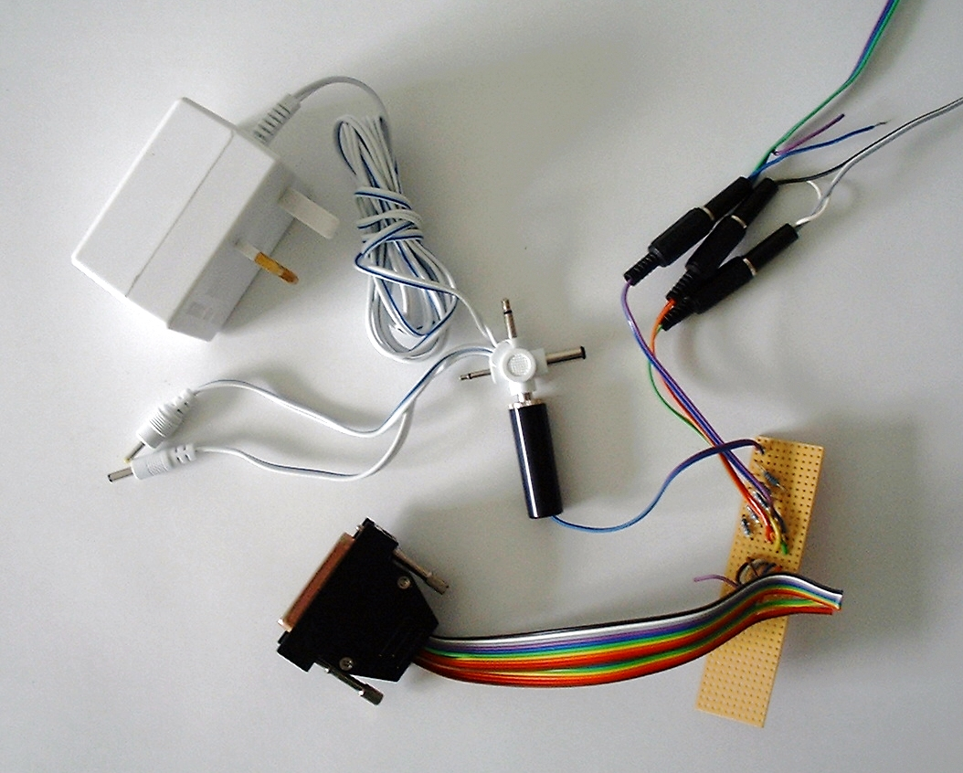
Initially a program was written to allow the crayons to be used to ‘write on the wall’. The projector was used to display a drawing surface, and a system to calibrate the crayon with the projected image was created using the four point warping method described in [16 p66-69]. A point on the drawing surface can be calculated by creating a perpendicular line to the surface from the crayon tip, or by intersecting a ray from the crayon with the surface (Figure 4). Both methods were initially made available because the former method avoids the use of, and therefore the inaccuracies in, the orientation data from the tracker, but the latter allows both pointing from a distance and touching the surface directly like a conventional whiteboard.
Figure 3: The buttons on the crayons are connected to the computer’s serial port via a special piece of hardware

The four point warping method transforms a point (x,y) on the wall to a point (x′,y′) on the projected image using the formulae below:

x′ = c₁x + c₂y + c₃xy + c₄
y′ = c₅x + c₆y + c₇xy + c₈

This warping method compensates for translation, scaling, shearing and keystoning of the projected image – the major distortions that will occur due to changes in the relative positioning of the projector and the surface. A calibration method such as this is preferable to the need for precise mechanical positioning of the projector and hence periodic adjustments. To calibrate the system, four points are projected in turn onto the drawing surface, and the crayon is used to select each one. The four pairs of points from the projector and the tracker are substituted into the warping equations, and Gaussian elimination is used to obtain the constants c₁ to c₈.

Code was developed using the DirectDraw API on Windows 2000 to access display devices and display double-buffered images on them. Initially the wall display and crayons were used via a Java interface and a Java program that was written to allow multiple crayons to be used to write on the wall and move graphical objects around using direct manipulation. Java objects were used to store the data for the graphical objects, so that the safety and functionality of Java was available on top of the hardware access and speed provided by the C++ routines. The buttons on the crayons trigger various drawing functions.
A

B

Figure 4: To get a point on the surface, a perpendicular can be used (A), or a ray can be used (B)

VNC
Virtual Network Computing (VNC)[14] is a remote display system developed by AT&T Research Laboratories Cambridge. It allows a computer 'desktop' environment to be viewed from anywhere on the Internet and from a wide variety of machine architectures (Figure 5). The VNC server program resides on the computer that would normally display its output directly on a screen. In the case of a UNIX machine the VNC server acts as an X server. The VNC client runs on the computer with the screen, displaying the desktop of the remote computer for the user to see. A remote framebuffer protocol allows the server to update the client’s framebuffer. The input side of the protocol is based on a standard workstation model of a keyboard and a multi-button pointing device. The client sends an input event to the server whenever the user presses a key or moves the pointing device.
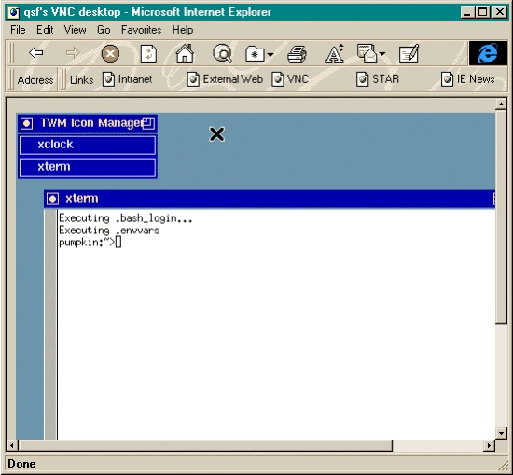
Figure 5: An X desktop being viewed from Microsoft Internet Explorer on a computer running WindowsPC [14]
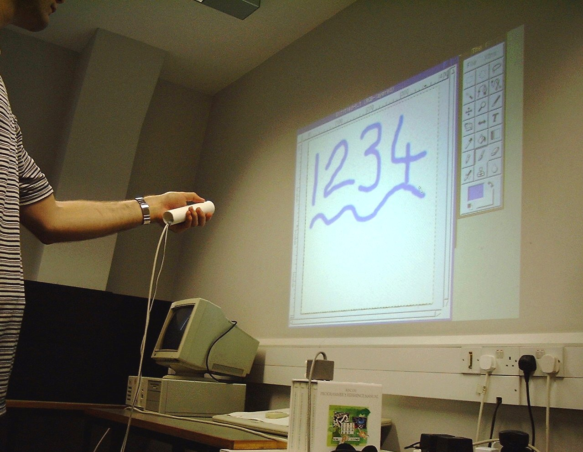
VNC, whose source code is made available by AT&T, was adapted to make the projected display into a VNC client that is controlled using a crayon. Figure 6 depicts the main parts of the system. The projected display and crayon input subsystems were created as described above, and a standard VNC client was modified to reroute display updates to the projector and synthesise mouse events from the crayon data. An unmodified VNC server allows the display to be used as the X Windows display of a UNIX machine. Figure 7 shows a standard X Windows drawing program being displayed on the wall and controlled with a crayon.
Figure 7: An unmodified X Windows drawing program controlled by pointing a crayon at the wall

EXPERIENCES
The Java drawing program was used to test the input and output devices. Use of the program indicated that the method where the cursor location on the drawing surface is determined by a perpendicular is no good, while that which uses a ray from the crayon is easy to use. Users found the former mapping between variables difficult to understand, but they could immediately achieve hand-eye coordination with the latter.
Modified VNC Client

User
Projected
Display
Crayon
Input
VNC Server
X Client
(Application Program)
Network
Figure 6: Elements of the VNC system with projected display. The shaded boxes are new or modified.

The VNC and Wall Display system was used with a standard drawing application (Gimp) to perform a demonstration for visitors to the Computer Laboratory. It was found to be easy to alternate between talking to the audience and controlling the application. The speaker can stand away from the screen to avoid hiding it from the audience or blocking the projector, and turning and pointing with the crayon naturally focuses the audience’s attention on the appropriate point.

Such a system makes it awkward to use a keyboard. Retaining access to the keyboard restricts the movement of the speaker, and the crayon must be put down before using two hands. Also it is undesirable to have the keyboard focus follow the pointer as happens with some window systems, because unlike the mouse which provides relative coordinates, the crayon provides absolute coordinates so to keep the pointer in one place, it must be held steady. Dasher [17] is a text entry system that uses a probabilistic language model and a continuously animated graphical interface controlled by a pointer. It runs unmodified on the wall display, and does not require the intricate movements of the text entry systems used on PDAs, and so provides an alternative to the keyboard (Figure 8).

An advantage of the remotely controlled wall display is that spectators can easily be invited to ‘have a go’. It was found, when demonstrating the system with a drawing application, that the crayon could be handed to a member of the audience and they could augment their questions to the speaker with actions on the wall display. The system can be used to show a presentation prepared with a package like Microsoft’s PowerPoint, but also supports the sort of improvisation possible with a blackboard.

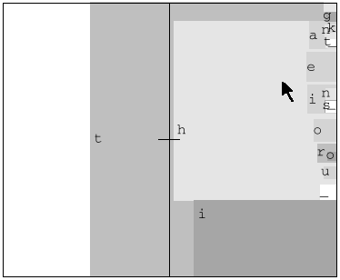
The magnetic tracker allows multiple devices to be tracked, and the Java drawing program initially created supports multiple crayons. A number of users can discuss a subject and add to a shared drawing as they please. The modified VNC client supports only one crayon because multiple pointing devices would not be compatible with VNC’s model of a computer terminal. Gains should be possible by combining the type of terminal described here with a graphical interface such as MMM [1] that is built around the idea of multiple users, each with his own pointing device.
Figure 8: Entering the word ’the’ using Dasher. The pointer is moved towards consecutive letters. The boxes around the letters grow smoothly from the right of the screen, while their sizes reflect the probability of the letters.

FUTURE WORK
Recent research has focused on developing large displays that use arrays of projectors, and digital cameras that are now inexpensive [6,9,12]. These do not rely on precise manual calibration of the projectors as such displays have in the past, but use feedback via the cameras to produce a self-calibrating system. The work described here will continue with the use of multiple overlapping projectors to create a foveal display that provides a high resolution fovea that accommodates the objects to which the user is currently attending, plus a lower detail periphery that holds objects that may quickly be brought to the fovea when they are used.

A horizontal desk-based display is being developed that gives the user a crayon in each hand. The foveal display and bimanual input over a large area form an interface more like the real desktop than the desktop metaphor.

Li [7] describes a system called SharedVNC that uses a proxy between the VNC client and server to merge events from multiple clients to form a stream to a single server, and duplicate frame buffer updates from a single server to multiple clients. This could be used with the wall display described here to allow real-time collaboration from two or more displays. Two desk-based systems will be linked in this fashion to support collaboration between physically distributed users. A sound channel will enable the participants to talk to each other, and the desks will provide a space analogous to that of a physical desk, but which is simultaneously accessible to all of them as they speak.

At Cambridge University students are taught in ‘supervisions’. A small group of undergraduate students (usually two) meet with a member of the academic staff or a postgraduate student to discuss aspects of a course and previously submitted written work. The participants in a supervision combine verbal interchange with work and learning in a small-group situation indicative of many commercial and academic meetings. The discussion in Computer Science centres around the written answers, notes and diagrams made during the supervision, and the course notes, textbooks and other written material. The supervision system will provide an application to test the linked desks as a medium for task centred collaboration – it is well understood and provides a benchmark for a computer-based medium. Experiments with real participants will determine the ease with which it can be used to convey ideas from teacher to pupil.

CONCLUSIONS
The hardware and software elements of large displays are becoming available to everyday computer users. They are desirable because they enable new ways of sharing information for copresent and distributed participants, and new interface styles which will facilitate new ways of presenting ideas, not just in lecture-style presentations, but in more interactive teaching environments.

ACKNOWLEDGEMENTS
This work was sponsored by Racal Research Ltd. UK (a Thomson-CSF Racal company).

REFERENCES
- Bier E.A., Freeman S., MMM: A User Interface Architecture for Shared Editors on a Single Screen, Proceedings of UIST ‘91, pp79-86, ACM, 1991
- Bolt R. A., “Put-That-There”: Voice and Gesture as the Graphics Interface, Computer Graphics 14(3) (Proceedings of SIGGRAPH ’80), pp262-270, ACM, 1980
- Bolt R. A., The Human Interface, Lifetime Learning Publications, Belmont, California, 1984.
- Elrod et al., LiveBoard: A Large Interactive Display Supporting Group Meetings, Presentations and Remote Collaboration, Proceedings of CHI ’92, pp599-607, ACM, 1992
- Fox A., Johanson B., Hanrahan P., Winograd T., Integrating Information Appliances into an Interactive Workspace, Computer Graphics & Applications, IEEE, May/June 2000
- Humphreys G., Hanrahan P., A Distributed Graphics System for Large Tiled Displays, Proceedings of Visualization ‘99, IEEE, 1999
- Li S.F., Stateless Client Computing, PhD Thesis, University of Cambridge Computer Laboratory, 2000
- Polhemus, http://www.polhemus.com/
- Raskar R. et al., Multi-Projector Displays using Camera-Based Registration, Proceedings of Visualization ’99, IEEE, 1999
- Rekimoto J., Saitoh M., Augmented Surfaces: A Spatially Continuous Work Space for Hybrid Computing Environments, Proceedings of CHI ’99, pp378-385, ACM, 1999
- Streitz N. et al., i-LAND: An Interactive Landscape for Creativity and Innovation, Proceedings of CHI '99, pp120-127, ACM, 1999
- Surati R.J., Scalable Self-Calibrating Display Technology for Seamless Large-Scale Displays, PhD Thesis, Massachusetts Institute of Technology, 1999
- Swaminathan K., Sato S., Interaction Design for Large Displays, Interactions 4(1), pp15-24, ACM, 1997
- VNC: Virtual Network Computing, AT&T Laboratories Cambridge, http://www.uk.research.att.com/vnc/
- Weiser M., The Computer for he 21st Century, Scientific American Sept 1991, pp 94-104
- Wellner P. D., Interacting with Paper on the DigitalDesk, PhD Thesis, University of Cambridge Computer Laboratory Technical Report 330, 1994
- Word D.J., Blackwell A.F., MacKay D.J.C., Dasher – A Data Entry Interface Using Continuous Gestures and Language Models, Proceedings of UIST 2000, ACM, 2000
- Yoder L.A., The State of the Art in Projection Display: An Introduction to the Digital Light Processing Technology, Texas Instruments, Available at http://www.ti.com/dlp/resources/whitepapers/

